____________________________________________________________________________________________________________
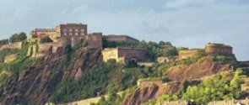
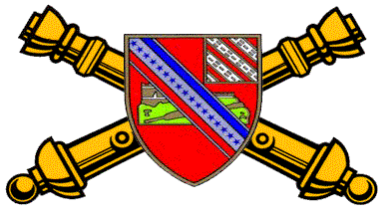
17 TH ARTILLERY REGIMENT

ASSOCIATION
THE CASTLE NEWSLETTER
_____________________________________________________________________________
Issue 6 ___ January 2005

HERALDIC TIMES
(Coat of Arms)

Shield:
Gules, a conventionalized castle of Ehrenbreitstein with ramp or on mount proper, debruised by a bendlet argent bearing two ribbons of the field and azure with seventeen mullets of the last. A sinister canton bendy of eight ermine and of the field.

Crest:
On a wreath of the colors, or and gules, a mount argent garnished vert, bearing a linden leaf proper charged with a fleur-de-lis argent.

Motto:
In Time of Peace Prepare for War.

Symbolism:
The field of the shield is red, the artillery color. The principal charge is the castle of Ehrenbreitstein bedruised by a bendlet carrying the American colors and seventeen stars, to signify the occupation of the castle by the 17th Field Artillery. The canton alludes to the arms of the 8th Field Artillery from which men were transferred to organize the 17th Field Artillery. The crest commemorates the two most noteworthy battle incidents. The White Mountain is for Blanc Mont. The leaf is taken from Verte Feuille Farm, on of the positions occupied by the regiment in the Soissons offensive; the linden leaf was chosen as being very common in that region. The fleur-de-lis is from the arms of Soissons.

DISTINCTIVE INSIGNIA
The distinctive insignia is the shield of the coat of arms.

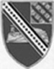

President’s Letter
Written By: Thomas R. Kurtz

During the past year the association has continued to grow and improve, which, without those who have supported the association this would have not been possible. On our web site, new items to the association “Gear” page have been added and Ed Hitchner has started posting veterans’ pictures. The association has contacted or has been contacted, by an additional 138 veterans whose names have been added to our veterans’ roster. We have lost contact with 46 who have moved and have not provided a new mailing address. There have been a few veterans contacted who wish not to be listed or have any contact with the association for their own personal reasons. We will respect their wishes.

The following members were elected or reelected during the annual membership meeting as officers of the association: Jack Stroud as 2nd Vice President, Jack Picciolo as Secretary and Rich Siebe as Treasurer. Congratulations to each on your election to your positions and thank you for stepping forward to run and maintain the association.

On a sad note, Daniel Lazenberry had to resign as the association secretary due to family heath issues. Thanks Daniel for the time and effort you put toward the association. We all wish Daniel and his family well.

The 2004 reunion was very successful. To those who attended, without your presence, the reunion would have not have been possible. Again thanks to all those veterans, spouses, family and friends that did attend. Special thanks to Richard Jones, Paul Fusco, Mike Burke and the all of the association officers who helped organize and make the 2004 reunion a success. Thanks to Annette Jones for making all of the ladies feel welcome and for providing the ribbons and pins for them to wear. I would also like to thank LTC Vincent Price for taking the time to come and address the association on the tour of the 1st Battalion, 17th Field Artillery Regiment in Iraq (2003-2004).
Thanks also to all who participated in the raffle and auction during the reunion. The items were donated and all proceeds were placed in the scholarship fund. Also, thanks to Gil Bernabe who donated $500 to the scholarship fund.

Annette Jones and Jane Fusco started a project to send packages to the soldiers of the 2d Battalion, 17th Field Artillery Regiment in Iraq. Donations were made by those who attended the reunion, and at the general membership meeting it was voted on to make a $200 donation and to cover any shipping cost. All of us should remember the soldiers of the “Steel” Battalion serving in Iraq and all of the servicemen and women who are fighting the war on terrorism in our thoughts and prayers. The names and pictures of the 17th Artillerymen who have died so far during “Operation Iraqi Freedom” have been posted on the association’s web site.

During the annual veteran’s day observance, at the Vietnam Memorial, Peter Coffin, Richard Jones and Richard Siebe laid a memorial wreath, in behalf of the 17th Artillery Regiment Association. Webster Cole, Paul Fusco and Rich Siebe made donations to cover the cost of the wreath.

And to all of the 17th Artillery Veterans who sent their regrets that they could not attend the 2004 reunion, hopefully, you will be able to attend an association reunion in the future. The 2005 reunion will be held in Seattle, Washington, 21-24 September 2005. This will be the first time for an association reunion on the West Coast.
If anyone has knowledge of any deaths, injuries or illnesses of any 17th Artillery Veteran or in their families, please contact our chaplain, Webster Cole. Since the last newsletter, the board, in the name of the association, has donated $100 to the Jeff and Kevin Graham Memorial Fund and $500 to the Family Return Group (FRG) of the 1st Battalion, 17th Field Artillery Regiment for their use in welcoming the soldiers back to Fort Sill during April 2004 from their deployment to Iraq.

I’m looking forward to seeing all of you at the next reunion in Seattle Washington, 21-24 September 2005. The association will mail out a second newsletter this year. If anyone would like to submit an article, please send it to the association secretary, Jack Picciolo, prior to July 2, 2005.

Thomas R. Kurtz
Association President

Reunion 2004
Written By: Norman R. Jones

As I look back over the past year I will say it was very fruitful. We have progressed faster than I expected. The growth of our association has been a team effort with Thomas R. Kurtz at the helm leading the way. We have found a lot of new veterans, but we also lost contact with some. I am asking that if you move, please give us you new address and lets keep in contact.

The association started working on the DC trip as soon as the reunion was over in October 2003. A lot of phone calls and time were put into getting everything coordinated. The event was still being worked on right up until our arrival date of November 10, 2004. There were a few things that changed within the last 10 days, but it all worked out for the good. I would like to thank all that helped get the event organized. I especially would like to thank my wife, Annette, for helping me do a lot of planning for the reunions since 1999. She has been very instrumental in helping get the wives’ attendance to a higher level. Our goal has always been to have the association family-oriented. The reunion was a tremendous success and had the highest attendance rate thus far.

This year we had veterans from all wars since WWII, and the association was represented from coast to coast. It was a pleasure having Vincent Price (Former BN Commander of the 1/17th Artillery) to address our group. He commanded the 1/17th Artillery in Iraq for a year. Vince and I have become friends, and when I need help with some military matters, I call on him. He is always interested in the association. He was interested in us having contact with the Commander of the 2/17th Artillery, which is in Iraq at the present time, and that contact was established.

I, along with Richard Siebe and Peter Coffin, had the honor of laying a wreath for the 17th Artillery at the Vietnam Veterans’ Wall. That particular event was coordinated by Paul Fusco. He even got the association 40 reserved seats at the ceremony. The seats were in front of the speaker’s stand and were appreciated by all that attended. There were several who had pictures made with the wreath. There were also three veterans from “D” Battery that joined us in taking pictures, two of them I had been working on to attend for several years. They were Marvin Rogers and Birdeye Middleton, accompanied with Gene Haase. I was glad that Marvin contacted Birdeye and Gene and was able to get them to attend. I hope to see the three of you at the next reunion. There were others that had their pictures taken also; they are on the reunion pictures page on our web site.

There are a lot of you that have made the association a success, and I certainly appreciate your help with the scholarship fund. It is gathering momentum as we go along. More and more folks are supporting it, and I would like to thank all that were a part of the fundraiser. We did well, and I’m sure we will continue. Thanks to all that attended.

We will see you in Seattle, WA.

Norman R. Jones
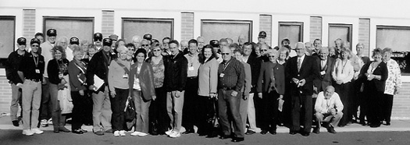

The following attended the 2004 reunion
(Washington, DC)

GW & Kathy Adkisson ---AR
Jack & Connie Barron ---WA
Wallace & Trndy Bates ---AL
Gil Bernabe ---VA
Dave & Judy Bickler ---OH
H.D. (Buck) & Bonnie Brown ---MD
Harold & Erma Brown ---MT
Mike Burke --- CA
Peter & Patty Coffin ---CA
Webster Cole ---TX
John Detreville ---NC
James Drennan ---VA
Lonnie & Peggy English ---SD
Neal Fouts ---NC
Paul & Jane Fusco ---NJ
Tom & Mary Gatzke ---WI
Matt Halloran ---ME
Gene Hasse ---VA
Ed & Nancy Hitchner---PA
Gene & Carol Johnson ---NY
Richard & Annette Jones ---TX
Richard Kane ---CO
Stephen R. Kane ---GA
Robert & Katharine Kinton ---NC
Tom Kurtz --- IL
Hanson & Jean Leach ---AL
W. Keith & Dorothy Mason ---TX
Mike & Becky Mason ---WA
Michael & Gwen Pearson --- AZ
Bob & Rose Ann Plata ---PA
Jerry & Lois Pifer ---OH
Jack & Carol Picciolo ---IL
LTC Vincent Price ---VA
Nolan & Betty Putman ---TX
F. C. Rash ---CA
Paul & Kathy Raymond---MA
Marvin Rogers ---AZ
Joseph & Franny Russo ---MA
Bert Ryan ---NY
Peter Schwarz ---MD
Paul Shepherd ---PA
Richard Shrout ---MD
Rich Siebe --- CA
Richard Smith ---NC
Jackie & Molly Stroud ---OH
Charles Riley ---NC
Mike & Rita Turner & Sons Derek & Lance ---CA
Terry & Margie Wallace ---NC

17TH FA Reunion
Written By: Katharine Kinton

Happiness is a group of Veterans gathered together with a common pride that they made our country and our world a safer, better place for all mankind to live in freedom. The bond of love, camaraderie and respect that grows during training, traveling, fighting and readjusting to daily living is enhanced with the strength each person has gained.

This bond of love extends to gatherings such as the 17th Artillery Regiment Association in Washington, D.C., November 10 to 13, 2004. Many had been to one or all of the reunions since November, 1999, and others, like Robert and Katharine Kinton, WWII, were there for the first time. The joy each person shared with each other made us welcomed and we knew we were among a group of the finest people on earth. We enjoyed the shuttles, metro rides and the long walks between, to see, hear, smell and enjoy our beloved Capitol City. We couldn’t stop looking and wooing.

Our Veterans’ Day at the Wall humbled us all and swelled our hearts with pride as we looked at each name knowing they were loved and mourned by so many families and buddies never to be forgotten. We also saw the men and women’s Vietnam, Korean and WWII Memorials plus the Jefferson, Lincoln and Washington Memorials. We saw so little of what was available; the choices were difficult but we could not see everything on one trip.

Let us not forget playing in the rain the third day because we didn’t let it dampen our spirits. We took a shuttle tour of the city with our driver being a naturalized citizen from India. He proudly stated he had lived in other countries, but none compared to the USA, “The best country in the world!” His personality and humor added to our ride and he tried to drive by all the sites we requested in addition to the ones on the program. Our perseverance was rewarded by observing the Tomb of the Unknown Soldier. We felt compassion and pride for the guard at the Tomb, for through the weather conditions, he didn’t miss a step. Kennedy’s grave flooded us with memories of the good and evil of the world. The mansion at Arlington touched us with joy as we enjoyed the splendor of a home of parents, children and friend in days of old. We saw the strength of the men who raised the flag on Iwo Jima, the silence of Ford Theater and the majesty of the Capitol and the White House. Yet, how can you only spend one hour in the magnificence of the Smithsonian museums? It had been a wonderful day.

Saturday came so quickly and many were checked out by noon. We collected in the dining room for a lovely banquet where Life Membership Coins and awards were given to many. A fine young man, LTC Vincent Price, spoke of what the 17th Artillery is doing in Iraq presently. Their jobs of fighting, patrolling, and discovering and destroying hidden arms are sweetened by the realization they are busy building schools and helping the citizens have a better life by sharing with them the meaning of freedom.

Thank you to all who planned the reunion and worked so hard for our pleasure. It was a huge success and God willing, we shall see all of you in Seattle, Washington, in November, 2005. In the meantime, have a wonderful and prosperous life this year.

Robert (WWII VET) and Katharine Kinton

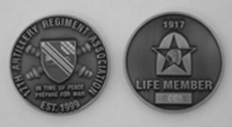
Life Member Coin

Life Members:

The association now has 53 Life Members. The following 17th Artillery Veterans have become life members of the association, since the 2003 reunion:

Eugene (Gene) Johnson - A 2/17 (1966-67)
Francis (Fran) C. Rash - C 2/17 (1965-66)
Delmar D. Beard - Hqs 2/17 (1967-68)
Charles E. Morrison - F 17th FA BN (1941-45)
Robert Gary Kohl - SVC 2/17 (1965-66)
Michael Dages - B 2/17 (1969-70)
Lonnie O. English - Hqs & C 2/17 (1968-69)
Webster Cole - C 2/17 (1970-71)
Leonard T. Elzie - Hqs 2/17 (1965-66)
Richard P. Carmody - Hqs & B 2/17 (1964-66)
Jerry E. Pifer - C 2/17 (1965-66)
Louis J. Mazzarella - C 2/17 (1969-70)
Richard J. Flower - C 2/17 (1965-66)
James M. Sherrill - Hqs 2/17 (2000-01)
Wallace L. Bates - B 2/17 (1968)
Richard A. Smith - A 4/17 (1974-78)
George A. Schaefer - Hqs 1/17 (1959-60)
Charles Riley - A 4/17 (1964-78)
Pete Schwarz - B 2/17 (1968-69)
Robert M. Kinton - C 17th FA BN (1941-44)
Robert L. Plata- C 2/17 (1964-66)
Gilbert (Gil) A. Bernabe - B & Hqs 2/17 (1967-68), HHB 3/17 (1976-78)
George Winton - B 2/17 (1969-70)
Harry O. Amos – Hqs 2/17 (1964-66)

1/17th "Professionals" by Bob Fleitz

1-17 FA "Professionals" was my first unit after the ADA Officer Basic Course. I got there in March 1976 just in time to go on the 6 month rotation to Augsburg Germany. The Army used to rotate entire brigades forward. Brigade 76 was a unit from 4ID (Ft Carson), plus 2 corps arty battalions - 1-17 (SP 155) and 2-18 FA (8"). We were stationed at Sheridan Kaserne, almost downtown Augsburg. What a great assignment for my first unit! Old German barracks, 6 weeks at Grafenwoehr and Vilseck, Redeye missile firings, travel around Europe, the infamous "Mutiny of the Turkish Cooks," the ancient telephone system, Linda at the O-Club - it was a great time. SSG Joe Dyer was the Redeye Section sergeant who started my real education as an army officer. Battalion commander was LTC Richard Beltson, battery commanders were CPTs Danny Tyner, Lee Baxter, Max Torrence, Bob Korkalo, and Bob Castle. I still have a couple of the commemorative beer steins we had made up.

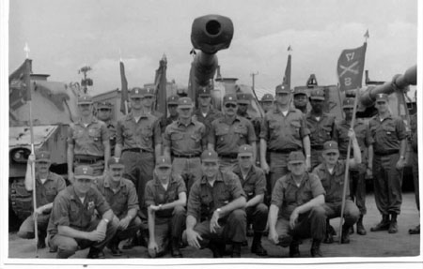

This picture of the officers of 1/17 FA taken at Ft Sill in about April 1978. Only three or four of us were left from the Augsburg trip. This was just before I left to go back to ADA-world.

Kneeling: 1LT Wayne Madewell, XO MAJ Kent O. Brown, S1 CPT Cooper, S2 CPT Jim DeCarlo, CO LTC Gene Wilson, 1LT Joe Rhodes, CSM Ned Foss, 1LT Steve Haley
2d Row: A Btry Cdr 1LT Charles Poure, B Btry Cde CPT Sleder, C Btry Cdr CPT Howard (Howie) Brosseau, HHB Cdr CPT George Alexander, SVC Btry Cdr CPT DeRoos
3d Row: 2lt Morales, (unknown), (unknown), (unknown), 1LT Steve Beacon (Survey), 1LT Bob Fleitz (ADA),

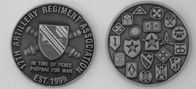
Association Coin

HISTORY OF THE 17TH ARTILLERY

ACTIVATION

The actual organization of the 17th FA Regiment was not implemented until 15 May 1917, one month after the declaration of World War I. On that date a selected cadre from the 8th FA Regiment was ordered to Camp Robinson, Sparta, Wisconsin, to organize the new unit. By 6 June 1917 the unit was officially entered into the records as an active Regiment. Colonel Albert J. Bowley, who later achieved recognition as a Lieutenant General and Commander of the Fourth Army (1938-39), became Commander of the 17th FA Regiment on 17 June 1917.
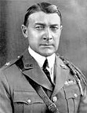
General Albert J. Bowley

WORLD WAR I
After six months of intensive summer and winter training the unit departed for France. There, in training at Camp du Valdahon, the unit was given Schneider 155mm Howitzers by the French Government, and was instructed in their use by the French Officers. On 26 March 1918, in the Rupt-Troyon battle sector, the 17th FA fired its first mission against the enemy. From that date until the conclusion of the First World War, the history of the 17th FA is one of continuous battle honors, sector participation, and citations for valor.
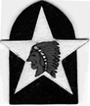
Headquarters 17th Field Artillery Regiment, A.E.F., Shoulder Sleeve Insignia (Patch), World War I
The Aisne Campaign was the first major trial for the American Forces in France, and it came at a time when the German Army was within forty miles of overrunning Paris. The 17th FA, one of the first American artillery units to participate in this campaign, supported the 2nd Division who succeeded in capturing the Belleau Wood, Vaux, and Hill 204, key points in stopping the German offensive.
As the American forces pressed forward they seized the initiative from the enemy and destroyed the last serious threat of German victory. In the Aisne_Marne Campaign, the 17th FA participated by supporting the 2nd Infantry Division’s capture of Soissons. During the fighting, a large number of German artillery pieces were captured. The men of the 17th FA turned the captured weapons around and put them to good use against their former owners. For their valor and energy in this battle the 17th FA received its first citation from the French, a Croix de Guerre with palm.
The ST Mihiel offensive resulted in the destruction of the German pocket concentration in this sector. This campaign was completely under American direction and brought great recognition to the American Forces in France. At 0100 on 12 September 1918, the 17th FA fired a barrage, which was extremely effective in terms of accuracy, rapid firing and concentration. As a result, when the infantry of the 2nd Division went over the top four hours later, little resistance was offered.
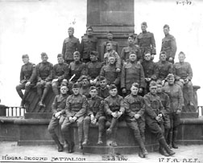
Headquarters 2/17th FA A.E.F. Ehrenbreitstein Castle

By October of 1918 the Germans were rapidly retreating back across France, but in certain isolated sections of the front, enemy resistance stiffened. On 3 October 1918 in the Meuse_Argonne Campaign, the 17th FA, under a heavy concentration of counterbattery fire, helped to deliver the supporting fire which enabled the infantry to capture Mont Blanc. It was here that the 17th FA received its second citation of the Croix de Guerre with palm from the French, for its “glorious part in the operations and engagements in the Campaign in October 1918.
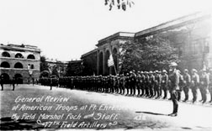
General Foch Reviews 17th Field Artillery Regiment,

On 4 August 1919, elements of the 17th FA returned to the United States to parade down 5th Avenue, New York, with the 2nd Division. The 17th FA was then regrouped and subsequently dispatched to Fort Bragg, N.C., where it remained until the Second World War. Having received two citations from the French during World War I, Marshall Ferdinand Foch personally presented to the unit the French award of the Fourragere in his visit to the United States 9 December 1921.

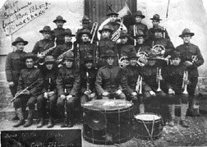
17th Field Artillery Regiment Band, World War I

18th Army Band (Inactivated)

The 18th Army Band, which was stationed at Fort Devens, Massachusetts, from 18 November 1948, until it was inactivated, traced its Lineage and Honors back to the Band Section, Service Battery, 17th Field Artillery Regiment, which was organized on 6 June 1917 at Camp Robinson, Wisconsin.

Korean Defense Service Medal

In February 2004, DOD announced the Korean Defense Service Medal (KSDM). Public Law 107-314 legislated the creation of a new medal to recognize military service in the Republic of Korea and the surrounding waters. Members of the armed forces authorized the KSDM and must have served in support of the defense of the Republic of Korea. The area of eligibility encompasses all land area of the Republic of Korea and the contiguous water out to 12 nautical miles and all air spaces above the land and waters areas.

The KSDM period of eligibility is July 28, 1954, to a future date to be determined by the secretary of defense. Servicemembers must have been assigned, attached, or mobilized to units operating in the area of eligibility and have been physically deployed in the area of

eligibility for 30 consecutive or 60 non-
consecutive days or meet one of the following criteria:

Be engaged in actual combat during an armed engagement, regardless of the time in the area of eligibility.

Is wounded or injured in the line of duty and required medical evacuation from the area of eligibility.

While participating as a regularly assigned air crewmember flying sorties into, out
of, within, or over the area of eligibility in support of military operations. Each day that one or more sorties are flown in accordance with these criteria shall count as one day toward the 30 or 60 day requirement.

Personnel who serve in operations and exercises conducted in the area of eligibility are considered eligible for the award as long as the basic time criteria is met. Due to the extensive time period for the KSDM eligibility, the nonconsecutive service period for eligibility remains cumulative throughout the entire period.

The KSDM may be awarded posthumously to any soldier who lost his/her life without regard to length of such service. Only one award of the KSDM is authorized for any individual.

Request for award of the KSDM to veterans, retirees, or their next of kin will be submitted to the National Personnel Records Center (NPRC), www.archives.gov, in St. Louis, MO. NPRC’s address is National Personnel Records Center, 9700 Page Avenue, St. Louis, MO 63132-5100. Request will include documents supporting service in Korea from 28 July 1954 to date to be determined. NPRC will add KSDM to the DD Form 214 by issuing a DD Form 215 (Correction to DD Form 214, Certificate of Release or Discharge from Active Duty. Members of the Army Reserve and National Guard should contact their current record custodian to have their records update.

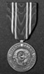

17th Artillery Regiment Association Scholarship Program
Written By: Thomas R Kurtz, Scholarship Committee Chairman

The association awarded its first scholarship grant, in May 2004, to Staci R. Siebe-Irish, in the amount of $500. Staci is a student at the Sacramento Campus, California College of Technology and is majoring in Interior Design. Staci is the daughter of Richard Siebe. Richard served, in South Vietnam, with the 2d Howitzer Battalion, 17th Artillery (1967-1968). The first scholarship grant was named in the honor of First Sergeant James A. Moore, United States Army, Retired. James was a life member of the association and served with the 2d Howitzer Battalion, 17th Artillery in South Vietnam (1966-1967). James passed away on October 19, 2003.

There were five requests for a 2003-2004 scholarship application packet and only one application packet was returned. The money for the second $500 grant was retained in the scholarship fund. The voting members of the 2003-2004 scholarship committee were Peter Coffin, Norman (Richard) Jones and Francis (Fran) Rash. I thank them for their time and effort they put toward this program.

For the 2004-2005 time period, the association’s general membership has authorized two scholarship grants, one for a thousand dollars ($1000) and one for five hundred ($500). A request for a scholarship application packet can be made to Thomas R. Kurtz, President and Scholarship Committee Chairman, at 703 South College Street, Lincoln, IL 62656-2523, (217) 732-4357 or by e-mail at: Kurtz_T@ msn.com

To be eligible for the 17th Artillery Regiment Association grants, the applicant must be a child or grandchild, of a parent or grandparent who has served with, or is presently serving with, any units of the 17th Artillery: Active, National Guard and Reserve Units. Those parent or grandparents, who have served or are serving, must have served or are currently serving under honorable conditions. If the parent or grandparent received a discharge under less than honorable conditions, then the applicant is not eligible. The term’s child and grandchild used above apply to both biological and legally adopted children. Foster children and grandchildren are not eligible.

If the applicant has been previously awarded a scholarship grant from the 17th Artillery Regiment Association, the applicant is not eligible to apply for another grant. Applicant must also be a graduating high school student (Class 2005) or a freshman, sophomore, or junior attending any college, vocational, or technical school. Scholarship grants will be awarded in all areas of study. The application with all supporting documents must be returned to:

Thomas R. Kurtz, President 17th Artillery Regiment Association, Attn: Scholarship Program, 703 South College Street, Lincoln, IL 62656-2523, by US mail no later than April 15, 2005.

The voting members of the scholarship selection committee for 2004-2005 are Webster Cole, Paul Fusco, Gene Johnson, Nolan Putman and Jack Stroud.

Since May 2004:
Total Number of Grants: 1
Total Amount of Funds Granted: $500

A Note from the Treasurer

Another year has come and gone and so has another reunion. The reunion in Washington D. C. last year was the best yet. We had plenty of time to meet and greet old and new friends, watch a few tapes, sight see, and participate in Veterans Day activities in the Nation’s Capitol. During the reunion we were able to take in almost $2,500 for the scholarship fund through the sale of association gear, a clock raffle (two 17th Artillery Regiment clocks), a clock auction, and donations. At this time I would like to thank the following for their generous donations to the scholarship fund both at the reunion and since the 2003 reunion:

Wallace Bates
Gilbert Bernabe
Terry Wallace
Francis C. Rash
Paul Raymond
Viron Kersh
Walter Larson

And to all those who have paid their association dues and bought association gear, thank you! We are still open to any donations that you wish to make. We also managed to sell almost $1700 worth of caps, t-shirts, coins and jackets to add to our general fund.

Our 2005 Reunion in Seattle is coming up in September, and I hope to see a lot of new faces there.
See you in Seattle,

Rich Siebe
Treasurer

Association Finances as of January 1, 2005
General Funds: $3470.68
Scholarship Fund: $5907.93

URGENT REQUEST: We need every 17th Artillery Veteran to keep his contact data current. Please notify us of any changes in your mailing or e-mail address. Contact any officer, or you may post your address by accessing the association’s home page and following the instructions. Contact me if you have any leads on any 17th vet. We need your assistance in keeping the association growing.
Home Page: http://www.17thartilleryregiment.org
Secretary: Jack Picciolo
1122 Lincoln St.
Lockport, IL 60441
(815) 838-3481
E-mail: Purrsfive@comcast.net
Web Page: http://persuaders65.org

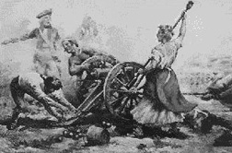
Molly Pitcher

Vietnam Veterans Memorial Fund's "In Memory Program"

The VVMF "In Memory Program" honors annually those who died prematurely as a result of the Vietnam War, but whose deaths do not fit the DOD's criteria for inclusion upon the Vietnam Veterans Memorial in Washington D.C. For information on this program contact Jack Picciolo or Richard Jones. Both have offered to help coordinate with any 17th Artillery Veteran or their families, whose friends or relatives that may quality for this honor.

Horse-Drawn Artillery
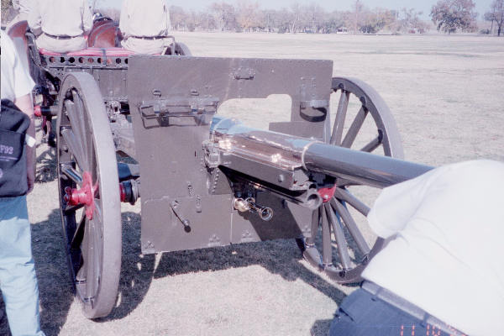

75MM close up
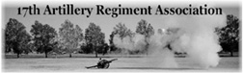

Association Officers 2004-2005

Thomas Kurtz ------------------ President *
Mike Burke -------------------- 1st Vice President *
Jack (Jackie) Stroud ---------- 2d Vice President *
John (Jack) Picciolo ---------- Secretary *
Richard (Rich) Siebe --------- Treasurer *
Norman (Richard) Jones ----- Past President
Webster Cole ------------------ Chaplain
John (Jack) Picciolo ---------- Historian
Mike Burke -------------------- Quartermaster
Vacant -------------------------- Parliamentarian
Vacant -------------------------- Judge Advocate
Vacant -------------------------- Program Director
Edward (Ed) Hitcher ---------- Webmaster

* Indicates elected office

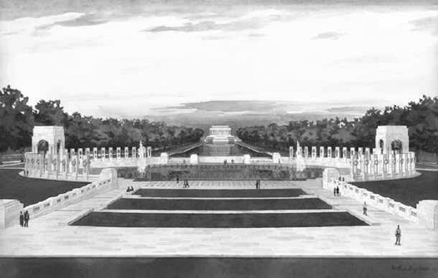
Overview of WWII Memorial, Washington, D.C.

This Newsletter, Castle # 6, was approved by the 17th Artillery Regiment Association Board of Directors

Thomas R. Kurtz
Association President

703 South College Street
Lincoln, IL 62656-2523
(217) 732-4357
Kurtz_T@ msn.com

