____________________________________________________________________________________________________________
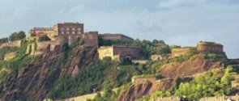
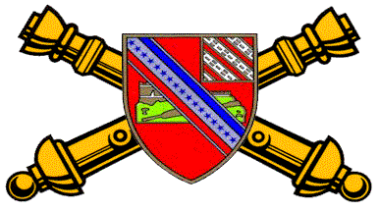
17 TH ARTILLERY REGIMENT

ASSOCIATION
THE CASTLE NEWSLETTER
_____________________________________________________________________________
Issue 7 ___ January 2006

HERALDIC TIMES
(Coat of Arms)

Shield:
Gules, a conventionalized castle of Ehrenbreitstein with ramp or on mount proper, debruised by a bendlet argent bearing two ribbons of the field and azure with seventeen mullets of the last. A sinister canton bendy of eight ermine and of the field.

Crest:
On a wreath of the colors, or and gules, a mount argent garnished vert, bearing a linden leaf proper charged with a fleur-de-lis argent.

Motto:
In Time of Peace Prepare for War.

Symbolism:
The field of the shield is red, the artillery color. The principal charge is the castle of Ehrenbreitstein bedruised by a bendlet carrying the American colors and seventeen stars, to signify the occupation of the castle by the 17th Field Artillery. The canton alludes to the arms of the 8th Field Artillery from which men were transferred to organize the 17th Field Artillery. The crest commemorates the two most noteworthy battle incidents. The White Mountain is for Blanc Mont. The leaf is taken from Verte Feuille Farm, on of the positions occupied by the regiment in the Soissons offensive; the linden leaf was chosen as being very common in that region. The fleur-de-lis is from the arms of Soissons.

DISTINCTIVE INSIGNIA
The distinctive insignia is the shield of the coat of arms.

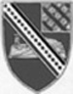

President’s Letter
Written By: Paul Fusco

I want to thank everyone for giving me the opportunity to guide this organization for the next new years. As I indicated at the reunion all decisions will be made with my executive board's input I feel it is very important that everyone is involved and kept abreast of everything that goes on within the organization. I also want to thank all of those who attended the reunion in Seattle, it was very enjoyable. I hope the next reunion in Charleston will be as enjoyable.

In the coming year I would like to see our membership increase, so I am asking all members to locate all those whom you served with and bring them on board. Encourage them to join the 17th Artillery Regiment Association. We as an organization have made great strides in our growth, and we will continue to grow. Our scholarships program is an excellent one. My hat's off to the all those who put it together. This year we are giving two one thousand-dollar scholarships, and one six hundred one. I want to thank all that have donated to the scholarship fund and made all these donations possible.
See you all in Charleston!

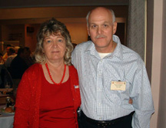
Paul and Jane Fusco
Past President Letter
Written By: Thomas R. Kurtz

The Presidency, of the Association, was turned over to Paul Fusco, at the Association’s 2005 Annual Banquet. Congratulations to Paul Fusco, on his election, and to Richard A. Smith for his election, to Association 1st Vice President. We all need to support our new association officers, plus those elected and appointed officers still in office. The leadership and growth, of the association, depends on volunteers coming forward to donate their time and talent, to lead and maintain the association.

I want thank the association officers who all supported me during my term of office. All were willing to help, provide assistance and guidance, in order for the association to grow and improve. I want to give special recognition to Mike Burke, who has served the past two years as 1st Vice President, and since 2000, as the Association Quartermaster. Mike needed a break and has given up his job as quartermaster. Jack Stroud has come forward and volunteered to fill the association quartermaster position. Now everyone needs to contact Jack Stroud, to place their orders. Remember 25% of the donations, for the associations “gear”, are placed in the scholarship fund. The remainder, of your donation, is used to maintain and run the association.

And to all of those who have given their time, efforts and donations to the association “Many Thanks”. The success of any organization depends that support given or provided by its members. I also need to recognize the spouses, family members and friends who have supported the association by their attendance at our annual reunions. Your attendance is always welcome and appreciated.

Finally, the 2005 Reunion has come and gone. Thanks to all of the association officers, who all contributed to the success of the 2005 Reunion. It takes all of the officers working together, as a team, to make our annual reunions successful. Also special thanks to Floyd Rucks and George Herbison, for providing information about the Seattle/Tacoma area. To Jack Barron who made the initial recon of the motel. To Mike Mason, who contacted the Fort Lewis Public Affair Office, to set up the tour of Fort Lewis. Of course, finally to the veterans, spouses, family and friends, that attended the reunion; which, without their attendance, the reunion would not have been truly successful. I hope all had a great time and are planning to attend the next reunion, 11-14 October 2006, in Charleston, South Carolina. I’m looking forward to see everyone again in October 2006.

My Trip to Washington DC
Written by Paul Fusco

Every year my veteran friends and I journey to Washington D.C. for the four days leading up to Veterans Day. We meet with old friends, make new ones and attend all of the activities we can. Every day there we pay our respects to our fallen comrades at the various memorials. It is not only a healing experience, but a very rewarding one. Upon arrival in Washington on November 9th we set out to visit with he wounded young men and women at Walter Reed Army Hospital. We have one on one visits and distributed phone cards donated by the Military Order of Purple Hearts. We also handed out American flags as well as prayer cards, but most important was our message to not only the veteran, but also to their families. We told them that we would be there for them and to contact us for any assistance they needed. . We told them that with all of the veterans organizations in the United States we can reach out to anywhere that help is needed and for them not to hesitate to ask for our help. I must tell you that every soldier that could respond to us indicated their desire to return to their units, even those who would never be able to do so. They actually thanked us not only for our visit, but also for our service to our country. The day was very rewarding, but also very exhausting. It was a day filled with many tears. As I sit back and reflect on our trip I'm asking everyone to seek out our newest veterans and help them in anyway you can, as they will always need someone to lean on and listen to their stories. We all know it is very good therapy. We as veterans must never let their sacrifices go in vain.

Bradley Beard Memorial

On Saturday, October 15, 2005 a flagpole dedication was held at subdivision near Chapel Hill, NC. It was to honor one of our own, Spec. 4 Bradley Beard, who was killed October 14, 2004 by a roadside bomb in Iraq. He was laid to rest in Arlington Cemetery. He was a member of 2/17th FA SP-4 Beard's First Sgt. Woodson Bond presented and raised the flag along with his platoon Sgt. Jose Rodriquez, and friend Sgt. Paul Southers. Rolling Thunder, a motorcycle group made up mostly of veterans was also present and they too presented a flag to the Beard family.

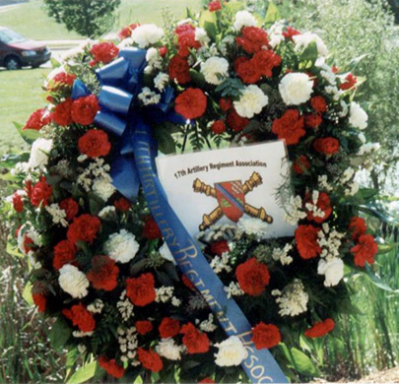

The 17th FA Regiment Association presented a wreath made out of red and white carnations, green leaves, a blue banner down the middle with 17th FIELD ARTILLERY REGIMENT ASSOCIATION on it. It also had an 8"x 11" copy of our crest in the middle.
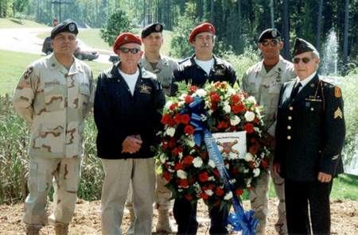
Members of Bradley’s Battery and 17th Artillery
Regiment Associations’ Members.
L-R: SSG Jose Rodriques, Charles Riley,
SGT Paul Southers, Richard Smith,
1SG Woodson Bond and Robert Kinton
Charles Riley and Richard Smith wore their standard issued red berets while Robert Kinton wore a class A WW II uniform as they acted as Honor Guard at the wreath. Richard Smith VP of 17th Association gave a brief speech about the history of the 17th and letting everyone know that Brad's death was not in vain. The cost of Freedom is not free. Brad's death was so that others in the world could live in freedom and not under dictatorship, freedom of speech, assembly, worship without the worry of imprisonment and torture. His parents were thanked on behalf of the 17th for the sacrifice their son had made for the cost of other's Freedom.

2005 Reunion, Seattle, Washington
Written By: Thomas R. Kurtz

The 17th Artillery Regiment Association’s 2005 Reunion was held at the Best Western Airport Executel, in Seattle, Washington. This was the first reunion held by the association on the west coast. Members, spouses and friends begin arriving as early as the afternoon of September 20, 2005. The afternoon was set aside to set up the hospitality room at the motel.

Wednesday, September 21, 2005 was for registration and signing in for all veterans, spouses and friends in the Rainier Suite. Some veterans, after signing in, spent the day touring the numerous tourist sites in the Seattle area or just sat around talking with old friends and comrades in the hospitality suite.

On Thursday, September 22, 2005 at 0830 A. M. the group departed the motel, by bus, for a tour of Fort Lewis. At the gate we were met by our guide and host, Matt Hinkle, from the Fort Lewis PAO, who welcome our group to Fort Lewis. Our first stop was at the Main Post Chapel, where a memorial service was held, to specially remember those soldiers from the 17th Field Artillery Regiment who made the ultimate sacrifice during “Operation Iraqi Freedom”. The Memorial Service was conducted by Chaplain (LTC) Dennis Newton. Chaplin Newton led the group, in the singing of the National Anthem, the Pledge of Allegiance and the singing of two hymns. He also gave an excellent talk about” Remembrance”. Paul Fusco read the names of those soldiers from the 17th Field Artillery Regiment, who died during “Operation Iraqi Freedom” (so far). (We all have to remember that the war still is going on and many soldiers are returning to Iraq, for there second or third tours.) I gave a brief talk about all who have served and died, while with the 17th Field Artillery Regiment since World War I. Many thanks to Chaplin Newton for setting up a well conducted memorial service. I know we all were thankful for his effort.

From the Main Post Chapel, the group, traveled to the Conference Room of the 1st Battalion, 37th Field Artillery Regiment, 3rd Brigade Combat Team, 2d Infantry Division. There the group was briefed by Major Robert Bennett, Battalion Executive Officer, on the organization of the battalion and their mission. After the briefing there was a question and answering period with some of the officers and soldiers of the battalion who had served in Iraq. I think we all enjoyed talking with the current generation of today’s soldiers. And we all thank them all for their service to this country. Many thanks to Major Bennett for the excellent briefing to our group, a job well done. After some group pictures we boarded the bus again. As the group moved by bus, from location to location, Matt Hinkle pointed out the different buildings and what they were for,

Our next stop was at the Cascade Community Club for lunch. Thanks to Fort Lewis Catering for providing and setting up the room where our group had lunch.

The last stop, on the tour, was at the Fort Lewis Museum. The Assistant Curator, Mr. Gregory Hagge welcome our group and gave a short briefing on the different exhibits located inside and out side of the museum. Richard Jones even found an old 8in SP, M55, Howitzer, on display, which he once served as Gun Chief on that type of howitzer. How long ago was that Richard?

Our tour ended about 2:30 P. M. and the group travel back to the Motel. After returning from the Fort Lewis tour, once again some when on individual tours of the Seattle Area or just when out for dinner.

My special thanks to Matt Hinkle, from the Fort Lewis Public Affairs Office, for setting up our itinerary and been our guide.

Friday, September 23, 2005 the morning and early afternoon was again available for individual tours of the Seattle area. At 3 P. M. the group was transported to Pier 55, on the Seattle waterfront, for the boat trip to Tillicum Village/Blade Island. At the Pier we all boarded the “Good Times II” for the trip to Blade Island. The trip took about forty-five minutes to reach Blake Island. Upon docking at Blake Island we departed from the boat. The group walked up the path to the Tillicum Village great cedar longhouse. Along the path an appetizer of steam claims was served. Then we proceed inside of the Lodge to go thru the buffet line for our salmon feast. We were seated as a group in the main hall for the meal. After the meal, a stage presentation of “Dance on the Wind” was preformed highlighting some of the traditional dance, myths and legends of the Northwest Coast. After the stage performance the group had some free time to see a demonstration of woodcarving and go through the gift store. About 8:15 the boat whistle sounded for all to board for the return trip to Pier 55. On the way back, all had a chance to view the Seattle skyline at night.

Saturday, September 24, 2005 starting at 10 P. M. the association annual general membership meeting was held in the Rainier Room. During the meeting, an election was held for the offices of Association President and 1st Vice President. Paul Fusco was elected the new Association President and Richard Smith as 1st Vice President. Congratulations to both on your election. I hope all members will support our new president and 1st vice president. Business of the association was conducted and voted on. A raffle drawing for two small framed 17th Field Artillery Colors was made and the winners were: Jack Picciolo and Charles Riley. Charles Riley donated his colors back for the auction. Again this year it seems Wallace Bates wanted both items and out bid everyone else. Thanks Wallace. All proceeds from the raffle and auction were place in the association scholarship fund. Just a side note, Charles is ordering another set of small colors for the 4th Battalion, in which he served.

Our Annual Association Banquet was held in the Olympic Room, starting at 12:30 P. M. The I Corps Color Guard, from Fort Lewis, presented the colors to start the banquet. I’m sure all in attendance agree the I Corps Color Guard was very professional and conducted the ceremony in a military manner. Again I have to thank Matt Hinkle for providing the color guard. Dinner was a little late being set up, so we proceed with a presentation of a Life Membership Plaque to Robert Kinton. Robert served with the 17th Field Artillery Regiment from 1941-1945. We also had another veteran from World War II, in attendance, Delmar Beard although not in the Army at the time. Delmar served as the Battalion Command Sergeant Major of the 2d Battalion, 17th Field Artillery in Vietnam 1967-68. Also I need to note the Korean War Veterans who also attend with their wife’s: Jack & Connie Barron, James & Marcia Frowein with their son Chris and Dan & Carol Lazenberry

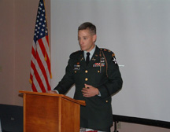
Major Thomas Munsey
Following the buffet meal, our guest speaker, Major Thomas Munsey, Operations Officer, 2d Battalion, 17th Field Artillery, 2d Brigade Combat Team, 2d Infantry Division gave us a slide presentation on the battalion’s mission and area of responsibility in Iraq. Major Munsey thanked the association on behalf the Battalion Commander, LTC John Fant, for the support the association provided the 2d Battalion during their deployment in Iraq. Major Munsey was accompanied by the Battalion Command Sergeant Major, CSM Shelton Kelly. LTC Fant had wanted to attend the reunion, but other commitments took priority. And thanks to LTC Fant for sending two key members of his staff to represent him and the soldiers of the 2d Battalion.
A 50/50 drawing was held and the winner was Frank Tamone. Frank donated $100 of his winnings back to the association scholarship fund. Richard Jones conducted another auction for the scholarship fund, of three patches worn by the 2d Battalion in Iraq. Richard Smith also donated an autograph copy of his book, “One StandsAlone” for the auction. Thanks to Richard Jones for conducting both auctions and also to Richard Smith for an autograph copy of his book. The new association officers were announced and the banquet was turned over to the new association president, Paul Fusco, for his comments and closing of the annual banquet.

I also need to thank Steven Kurt Wardrum for the opening and closing prayer at the banquet. Steven you did an outstanding job. Steven filled in for the Association Chaplain Webster Cole who didn’t attend this year’s reunion. It’s the first reunion that Webster has missed a reunion. It also should be noted that Jack Stroud will be the new association quartermaster once he gets sit up. Mike Burke will continue the job until Jack gets ready.

Last, as I was leaving Don Arceneaux made a $100 donation to the scholarship fund, thanks Don.

Thanks to Jack Barron who made a reconnaissance of the motel over a year ago and Mike Mason for contacting Fort Lewis and set up the tour. And of course all of the association officers, it takes all doing their part to make the annual reunions a success.

Even thought our attendance record was not broken this year. I thank all for attending this year’s reunion and hope everyone had an enjoyable time. I hope to see all again, at the 2006 Reunion in Charleston, South Carolina.

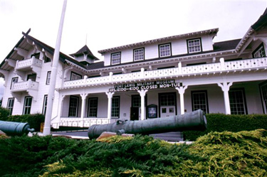
Military Museum at Fort Lewis, WA
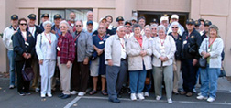

Attended the 2005 Reunion (Seattle, Washington).

GW & Kathy Adkisson ---AR
Don Arceneaux --- ID
Jack & Connie Barron ---WA
Wallace & Trudy Bates --- AL
Delmar & Pat Beard ---TX
Peter Coffin ---CA
Richard & Phyllis Flowers---IL
James & Marcia Frowein with son Chris---IL
Paul & Jane Fusco ---NJ
Richard & Annette Jones ---TX
Robert & Katharine Kinton ---NC
CSM Shelton Kelly---CO
Thomas Kurtz --- IL
H. Bruce & Fran Latour---TX
Daniel & Carol Lazenberry---TX
Mike & Becky Mason ---WA
Major Thomas Munsey---CO
Jack Picciolo ---IL
Paul Raymond---MA
Charles Riley---NC
Joseph Russo ---MA
Rich Siebe --- CA
Richard Smith ---NC
Jackie & Molly Stroud ---OH
Frank Tampone---MA
Mike Turner ---CA
Steven Kurt Wardrum---OR

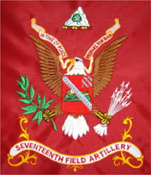\
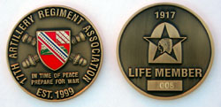
Life Member Coin

17th Artillery Regiment Association Life Members:

The following named 17th Artillery Veterans have become Life Members of the 17th Artillery Regiment Association, since the last newsletter (July 2005).

060 Leonard Spence (C Btry 2/17 1965-1966)
061 Terry Wallace (SVC Btry & A Btry 2/17 1968)
062 Lyndle E. Claus (SVC Btry 2/17 1965-1966)
063 Richard R. (Dick) Graves (HQs Btry 17th FA BN 1953-1954)
064 Daniel L. Lazenberry (B Btry 17th FA BN 1952-1953)
065 Robert L. Hallahan (C Btry 2/17 1961-1963)

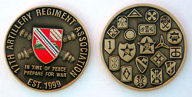
Association Coin

Membership Annual Dues

The following named 17th Artillery Veterans have paid their Association Membership Dues, since the last newsletter, as of December 31, 2005

2005 Dues

GW. Adkisson Ron Skirvin
Tom Jones Paul Raymond

2006 Dues

Steve Kurt (Om) Wardurm Shelton Kelly
John Detreville Bert Ryan
David Blubaugh Roger Nadeau
James Caiella James Stanley
Buddy Armstrong Dave Rowell

HISTORY OF THE 17TH ARTILLERY

17th Field Artillery Battalion
“Persuaders”
Korean War 1950-1953

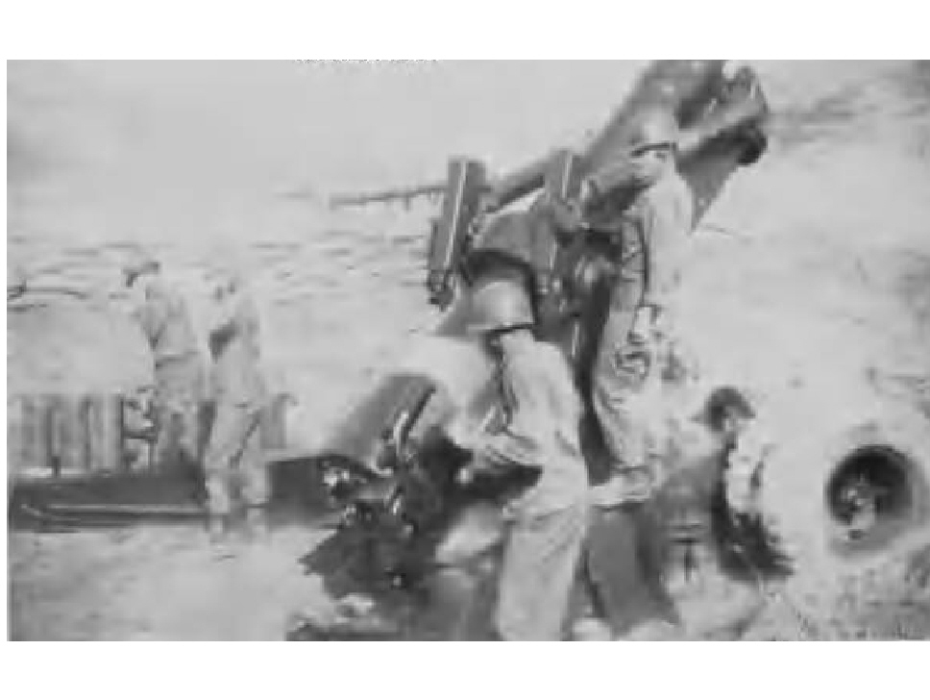
8 inch Howitzer in full recoil, Charlie Battery 1951

After World War II, the 17th Field Artillery Battalion was deactivated on April 16, 1946, at Camp Kilmer, New Jersey. The re-activation, for the 17th Field Artillery Battalion, came again August 1, 1946, at Fort Sill, Oklahoma. The battalion was used, as school troops, for the Artillery School. In December 1948, the battalion was reorganized and equipped with 8 inch (Towed) Howitzers (Tractor-drawn).

When North Korean invaded South Korea, on June 25, 1950, the 17th Field Artillery Battalion was located seven thousand miles away at Fort Sill, Oklahoma. Two months later, on August 25, 1950, elements 17th Field Artillery Battalion landed at Pusan, becoming the first heavy U. S. Army Artillery, in Republic of South Korea. The battalion was assigned to the Eighth U. S. Army Korea. Short of personnel and with an inadequate supply of ammunition. Only one firing battery, Battery C, plus two howitzers, with crews from Battery A, were initially committed to action. The battalion was also assigned two officers and two hundred soldiers, from the Republic of South Korea Army to be used as canoneers, wiremen and machine gunners.

In mid- September1950, the battalion was attached to I Corps, in support of the 1st Cavalry Division. Battery C fired the battalion’s first rounds, during a registration, on September 14, 1950. An hour later, Battery C fired its first counter-battery mission, which destroyed two North Korean artillery pieces. Not since April 29, 1945 had the 17th Field Artillery Battalion fired their howitzers, in combat, supporting American ground forces.

In late September1950, United Nation troops broke out of the Naktong Perimeter, attacking north to link up with the troops of the Inchon Landings. The battalion then moved northwest to Waegwan. At Waegwan, Batteries A and B remained in an assembly area; while Headquarters Battery, Battery C and Service Battery followed in the rapid pursuit of the North Korean Army. During this time period there were series of long road marches with little firing.

Batteries A and B moved north from Waegwan, in October 1950, to rejoin the battalion on the outskirts of Kaesong There the battalion was place in Eighth Army reserve, for training and maintenance. When the advance elements, of the United Nation Forces, reached the Yalu River, in early November 1950 and there was a possibility of the war ending early. The attached two hundred, Republic of South Korean Soldiers reverted back to the control of Republic of South Korean Army. A brief ceremony was held in their honor, at which time the 17th Field Artillery Battalion Colors made their first official appearance, in Korea.

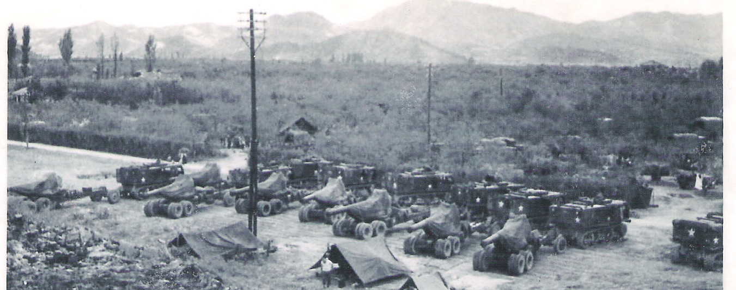
Able Battery and Baker Battery at Waegwan, South Korea 1950

The training and maintenance period was cut short in mid- November1950. The battalion then moved north, to the vicinity of Kunu-ri, and was attached to the 1st Cavalry Division, minus Battery B. Here the battalion occupied different firing positions and Battery A fired its first rounds of the war. Battery B was attached to the 25th Infantry Division and occupied its first combat position, a few miles north of Sinanju. Later in November 1950, Battery B rejoined the battalion, in the Kunu-ri area.

On November 23, 1950 the battalion was relived of its mission supporting the 1st Cavalry Division. The following day they were attached to IX Corps, supporting the 2d Infantry Division. That morning, the battalion moved into new positions, in the vicinity of Kujang-dong, still expecting to move north to support the 2d Infantry Division, in their rapid pursuit of the North Korean Army. Here an air observer spotted an estimate two hundred enemy soldiers. At the time, they were thought to be North Korean. No one realize then, that they were Chinese Communist Forces soldiers. In late November 1950, the Chinese Communist Forces were moving into positions; to infiltrate, cut off and destroy the United Nation Forces in a counteroffensive of massive attacks.

In the morning of November 25, 1959 the battalion had recon positions to move further north. Due to the roads being jammed, the move was put off and they planned to move the following day. Early that night, the Chinese Communist Forces waded the Chohgchon River and attached, in force the units of the 23rd Infantry Regiment and overran the 61st Field Artillery Battalion, just north of the battalion’s location. The following morning, the battalion was ordered to move south towards Sunchon. Over the next couple of days, with enemy pressure, on the entire 2d Infantry Division, the battalion moved south. The Chinese Communist Forces had also had overran the South Korean Divisions, located on the right flank of the 2d Infantry Division. The battalion moves were often delayed or temporary halted due to the supply road being jammed with vehicles. When the battery commanders reconnoiter, for new position south along the road to Sunchon, they found road south of Kunu-ri, for several miles jammed with vehicles. Vehicles returning, from the south, also reported that the road had been cut, by the Chinese Communist Forces and it was impossible to get through from Kunu-ri, south to Sunchon.

On November 29, 1950, the battalion fired defensive fires covering the withdrawing units of the 2d Infantry Division. During the night Battery A, started firing its missions at thirteen-hundred yards, charge seven. By the early the next morning, fire missions were being fired at thirteen hundred yards, charge one. Here the battalion commander laid out plans for three courses of action for the battalion. One was to return to Kunu-ri, block the traffic on the road to Anju, long enough to move the battalion on the road west, to Anju. Second was to move south, on the road to Sunchon, on orders from the 2d Infantry Division, when the roadblock south of Kunu-ri was open. Third was stay and fight, until forced to destroy their equipment. Then fight its way south on foot as a battalion. The 2d Infantry Division had sent the remainder of the 9th Infantry Regiment to clear the foot hills along the roadblock south of Kunu-ri. On morning of November 30, 1950, the remaining fighting elements of the 23d Infantry Regiment were committed to help the 9th Infantry Regiment in clearing the Kunu-ri roadblock, as the combat power of the 9th Infantry Regiment fighting had been greatly reduced from previous combat.

At 0800 hours on November 30, 1950, the battalion received orders to move south on the Sunchon Road. The battalion commander gave orders to move the battalion as a fighting column, with the tractors and howitzers in the lead, followed by the wheeled vehicles with the rest of the equipment. Vehicles tops were to be taken off, windshields down, machine guns mounted and the men equipment to fight as infantrymen. Order of march was Baker, Able, Headquarters, Service and Charlie. The battalion began moving south slowly towards Sunchon at about five miles per hour.

Around noon the battalion was halted near a deserted quartermaster supply dump of the 25th Infantry Division. Here many the soldiers of the battalion, lacking proper winter clothing, loaded up on quartermaster supplies, especially overcoats. The delay was for about two hours, during which time the remaining fighting forces of the 9th and 23d Infantry Regiments attempted to reduce the enemy forces position along the flanks of the roadblock.

Near the quartermaster supply dump there had been approximately one hundred American and South Korean soldiers sleeping on the ground under command of a captain. These soldiers loaded up on Battery A vehicles prior to the battery moving again. With the temperature around zero, vehicles bumper to bumper, the column moved down the road. The road was dry and most places wide enough for two way traffic. There were low hills along both sides of thousand-yard wide valley. After moving in a slow and halting manner, for about two miles, the column passed between Chinese Communist Forces firing machine guns and mortars from both flanking ridges. With single lane and clogged traffic, the battalion attackers had to be beaten off by 30 Cal. and 50 Cal. machine guns mounted on the prime movers. Vehicles were often stopped, as the soldiers would take cover in the ditches along the roadsides. Occasionally friendly aircraft would strafe the hills along the road that would quiet the enemy machine guns. This action would offer a chance for the column to start moving again slowly again, until enemy machine guns opened up again. During one halt, a large number of South Korean soldiers came through the enemy occupied hills on the columns left flank, which joined the column. They were disorganized and some were without weapons.

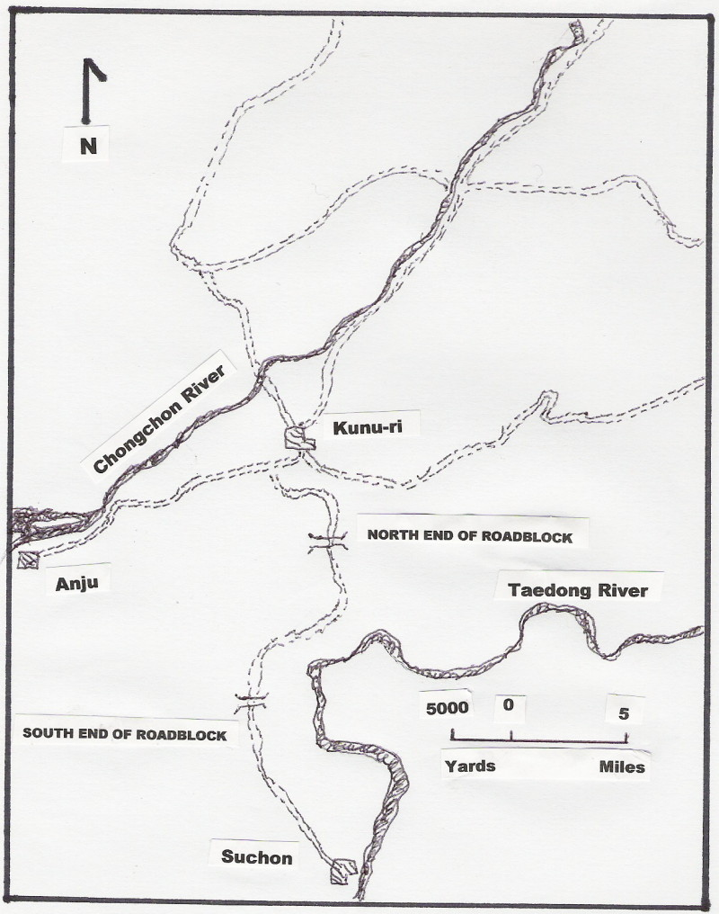
Kunu-ri Roadblock November 1950

Just before dark, when it looked like the battalion would be stuck in the middle of the roadblock, the column started moving again. Additional help came, as a twin 40mm came past the column to take the lead in front of Battery A and started firing at all suspected enemy positions. The battalion kept moving at night, driving in blackout drive. This made it difficult to identify abandoned vehicles along the side of the road. The battalion had passed between twenty-five to thirty abandoned vehicles, along the seven-mile roadblock. The column had moved slowly, not only due to enemy fire from the flanks. But also at the southern end of the roadblock, a two-lane concrete bridge had been destroyed. This causes the withdrawing vehicles to use a bypass and ford a several foot deep stream. Upon reaching the south end of the bridge bypass, the battalion found it blocked by two abandoned vehicles. As the battalion was clearing the abandoned vehicles, in the ford, two tanks came from the south with their lights on. The tanks lights lit up the soldiers trying to clear the ford, which cause the enemy forces to open up with mortar and machine gun fire. After this action, the tanks turned their lights back on and fired at the enemy positions. With the ford cleared and it wasn’t until 2130 hours that the last of vehicle of Battery A moved pass the ford. The remainder of the battalion’s column followed, with the wounded inside of the vehicles or being carried on the fenders. The battalion had loss twenty-two vehicles, eleven trailers and one howitzer, with one soldier killed and sixteen wounded; during the battalion’s withdraw thru the Kunu-ri roadblock. The other artillery battalions and units of the 2d Infantry Division that followed were not so fortunate. Soon after the battalion column cleared the ford, An M-6 tractor towing a 155mm howitzer stalled in the middle of the ford, which effectively blocked the withdraw route for the units that followed. This resulted in the vehicles north of the ford being abandoned and the personnel walk out. On the afternoon of December 1, the battalion was attached to the 1st Cavalry Division and occupied positions near Chasan, five miles south of Sunchon.

The first part of December 1950, the battalion continued firing in support of the United Nation Forces on their southward withdraw to the area around Seoul. With additional equipment losses, during this time period, the battalion assigned the personnel and equipment, from Battery C to the other two firing batteries. This left the battalion with only two firing batteries, one with five howitzers and the second with four howitzers. Late in the month of December 1950, the battalion reorganized again, to three firing batteries.

With the start of a new year, the battalion was placed in Eight Army reserve and order to move south by rail and road to Pusan. At Pusan, the battalion was attached to the 2d Logistical Command for a period of maintenance, training and re-equipment. There the battalion personnel additionally performed miscellaneous duties, which included convey protection in the rear areas.

After the re-equipment and training, in early February 1951, the battalion again was ordered to move north, by road and rail, to support I Corps. During the months of February and March 1951 the battalion or its batteries supported the 24th Infantry Division, 25th Infantry Division and the 1st Cavalry Division. In late March 1951 the Chinese Communist Forces offensive grounded to a slow halt.

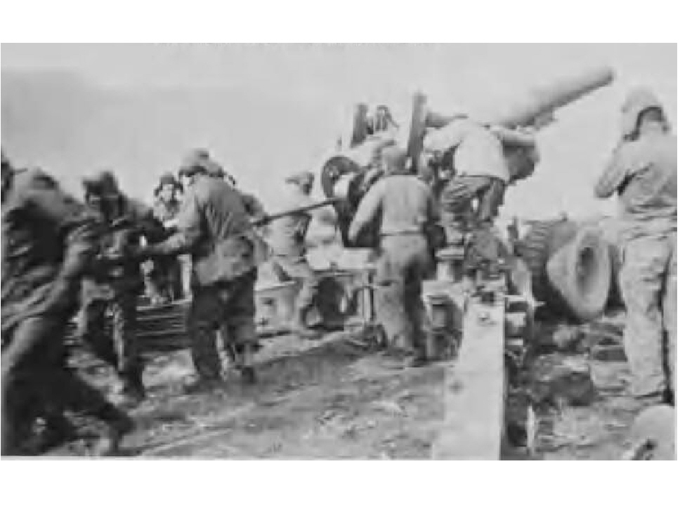
Cannoneers of Charlie Battery loading their
Howitzer 1951

In early April 1951, Battery B was supporting the 1st Cavalry Division, at the Hwachon Reservoir. The remainder of the battalion was moved, to join Battery B, when additional fire support was required. It was during this operation, that a battalion-wide contest was held for a battalion name. The name selected was “PERSUADERS”. Late in April, an enemy penetration, on the battalion’s left flank, caused the battalion to displace and still support the withdrawal of the 1st Marine Division.

From late April 1951 to July 1951, the battalion or its batteries supported I Corps, IX Corps, 7th Infantry Division, 24th Infantry Division, 1st Cavalry Division and the 1st British Commonwealth Division. During July 1951, the employment of a single howitzer, or by platoon, was started against special targets. A single howitzer or a platoon would move forward, at daybreak, fire its missions and return by dark. Special missions continued during the months of August to December 1951. In mid-October 1951 Battery A was issued two self-propelled 8 inch howitzer, to replace two of their 8 inch towed howitzers. When the two towed howitzer were returned, Battery A became a six gun howitzer battery. The two self-propelled howitzer proved to be useful in deployment with direct fire, assault fire and indirect fire against critical targets.

The two self-propelled howitzer, in early November 1951 thru January 1952, were placed at different time periods under the operational control of the 9th, 10th, 936th and 955th Field Artillery Battalions. When the self-propelled howitzers returned to battalion control, one self-propelled was placed in Battery A and the second self-propelled was placed with Battery C.

In the months of November, December 1951 and January 1952, the battalion or its batteries supported units of I Corps, IX Corps, 1st British Commonwealth Division and the 1st Republic of Korea Division.

In mid-January 1952 the two self-propelled howitzers, as a platoon, were placed under the operational control of the 189th Field Artillery Battalion, 45th Infantry Division. In February 1952 this platoon was expanded with additional equipment and personnel, from the resources within the battalion. Thus, Battery D, 17th Field Artillery was formed. There had been an earlier attempt, to form an additional battery, in October 1950, which never became operational.

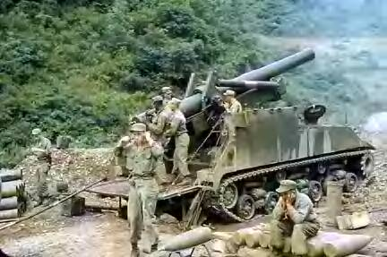

One of the two self-propelled howitzer
Of the 17th Field Artillery Battalion 1952

From January 1952 thru July 1952, the battalion or its batteries support units of I Corps, 3rd Infantry Division, 1st Marine Division and 1st British Commonwealth Division. Battery D became non-operational in July 1952 and its equipment and personnel were redistributed within the battalion. Again the self-propelled howitzers were returned, one each to Battery A and Battery C. At the end of August 1952 the battalion had been in Korea for two years, during which, the battalion fired a total of 168,758 rounds.

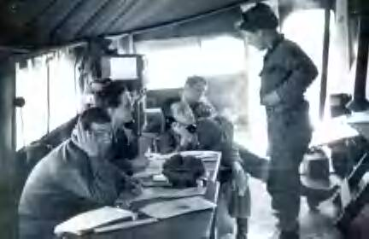
Battalion Fire Direction Center during a fire mission 1952

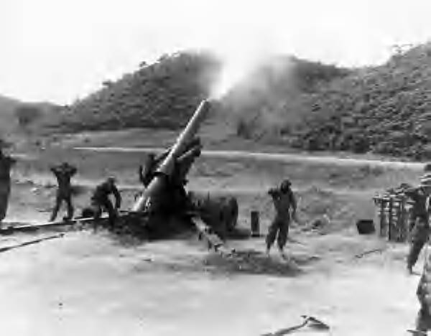

Able Battery firing in support of the 45th (US) Infantry Division
North of Yonchon, Korea, May 27, 1952
(Signal Corps Photo #10-340-2/FEC-52-14564)

The remainder of 1953, in the final months of the war, the battalion was deployed along the western front lines. They were one of seven artillery battalions attached to I Corps. With the positioning, of the firing batteries, the battalion could cover, from the Yellow Sea inland seventy miles. The firing batteries were positioned, with Able Battery on the right, Baker Battery in the center and Charlie Battery on the left. Here the battalion stayed in their positions until the armistices was signed on, July 27, 1953
From August 1950 to July 1953, the 17th Field Artillery Battalion had fought in harsh weather climates ranging from extremely cold winters; heavy rains of the monsoon seasons, and hot humid summers. The battalion had moved the length of Korea, over rough mountain terrain; often along unimproved and at times dangerously narrow roads. During which, the 17th Field Artillery Battalion supported all three Corps, of the Eighth Army, and twelve divisions of the United Nations Forces.

The 17th Field Artillery Battalion, during the Korea War, had no organic ground forward observers sections and had to depend on their Aviation Section and outside resources for their targeting.

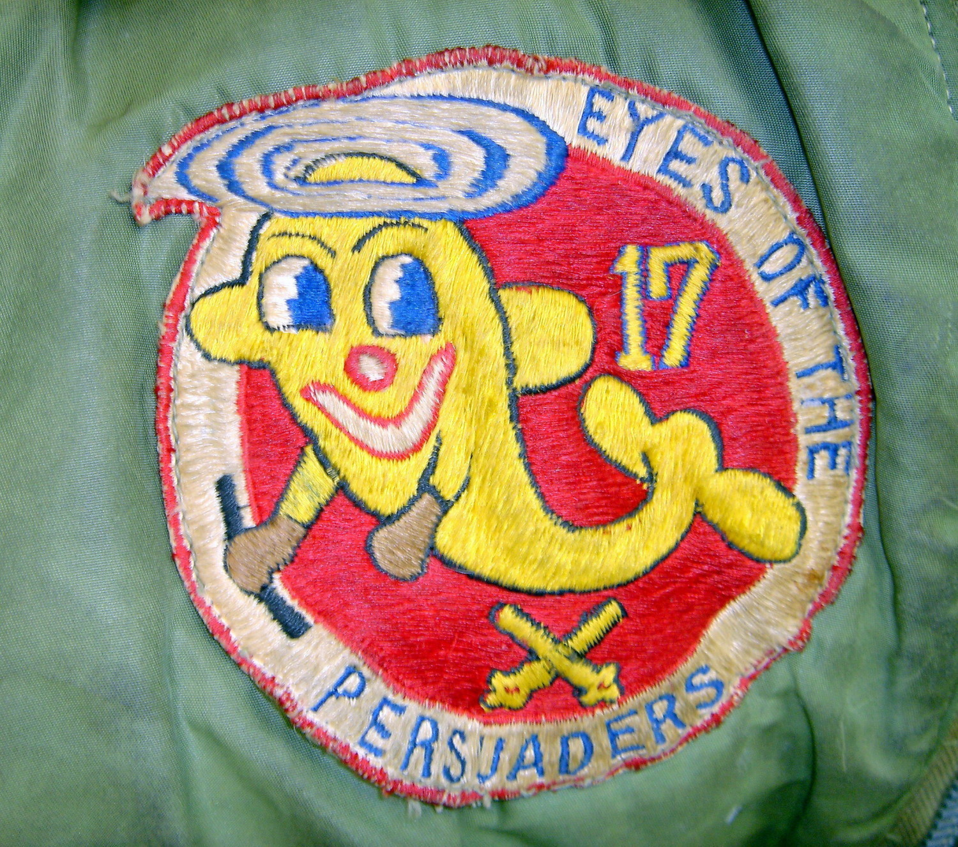
Aviation Section Patch 1953

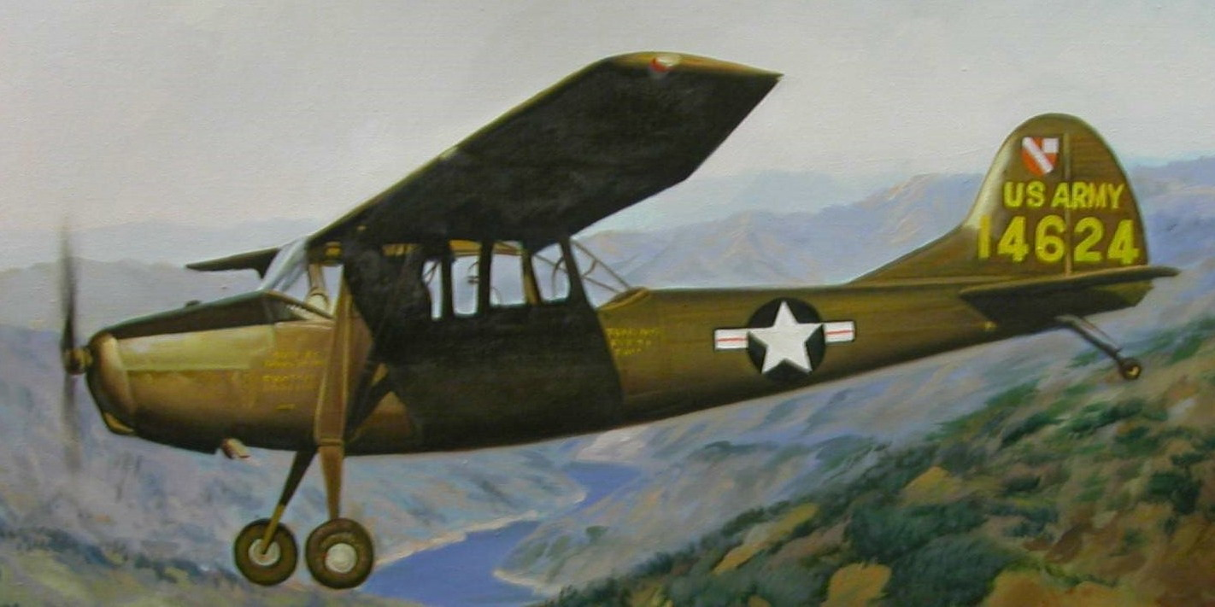

Flying over IMJIN River 1953

After the armistices, the 17th Field Artillery Battalion remained in South Korea and later was assigned to I Corps Artillery. The battalion was inactivated on June 1, 1958. On July 31, 1959 Headquarters and Headquarters Battery, 17th Artillery Group and the 17th Field Artillery Battalion, 537th Field Artillery Battalion were consolidated, reorganized, and re-designated as the 17th Artillery, a parent regiment under the Combat Arms Regimental System.

With lineage to Battery A, 17th Field Artillery constituted on July 1, 1916. Battery A was reorganized and re-designated on June 1, 1958 as Headquarters and Headquarters Battery, 1st Howitzer Battalion, 17th Artillery (organic elements constituted April 24, 1958 and activated June 1, 1958.) Operational control of I Corps Artillery, Eighth Army (U. S.), Korea.

The 17th Artillery was re-designated September 1, 1971 as the 17th Field Artillery. Withdrawn July 16, 1988 from the Combat Arms Regimental System and reorganized under the United States Army Regimental System.

Korean War Campaign Participation 17th Field Artillery Battalion:

- UN Defensive
- UN Offensive
- CCF Intervention
- First UN Counteroffensive
- CCF Spring Offensive
- UN Summer-Fall Offensive
- Second Korean Winter
- Korea, Summer-Fall 1952
- Third Korean Winter
- Korea, Summer 1953

Korean War Honors 17th Field Artillery Battalion:

Presidential Unit Citation (Army), Streamer embroidered HONGCHON (Battery B, 17th Field Artillery Battalion; cited; DA GO 72, 1951)

Presidential Unit Citation (Navy), Streamer embroidered WONJU-HWACHON (Battery C, 17th Field Artillery Battalion, cited; DA GO 38, 1957)

Navy Unit Commendation, Streamer embroidered PANMUNJOM (Battery C, 17th Field Artillery Battalion, cited; DA GO 38, 1957)

Republic of Korea Presidential Unit Citation, Streamer embroidered KOREA (17th Field Artillery Battalion, cited; DA GO 54, 1974)

References:
1. Linage and Honors, 17th Field Artillery
2. Lineage and Honors, 1st Battalion thru 8th Battalion, 17th Field Artillery Regiment
3. “The Persuaders in Korea” A brief, unofficial history of the 17th Field Artillery Battalion in Korea (August 1950-August 1952,
Compiled by David Jones, dated 1953.
4. Documents of the 4th Historical Detachment: Interviews of Personnel, 17th Field Artillery Battalion; “Action at Kunu-ri, 17th Field
Artillery Battalion, November 24, 1950- December 1, 1950: conducted by Captain Edward C. Williamson
5. Army Historical Series “Combat Actions in Korea” CMH Publication 30-2; Chapter 5, Artillery at Kunu-ri, by Russell A. Gugeler
6. History of then 2d Howitzer Battalion, 17th Artillery, USAAMS Library, dated 1967.

Pictures Courtesy of:
Jack I. Barron
James (Dick) R. Graves
Bruno A. Kalkowski Jr.
Leslie B. Scott

2006 17th Artillery Regiment Association Scholarship Program.
The association’s general membership has voted to authorize three scholarship grants for 2006. Two grants for a Thousand Dollars ($1000) each and a third grant for Six Hundred Dollar ($600). Also starting this year, the association general membership has voted to add great-grandchildren to those who are eligible for a scholarship grant.

I have appointed Thomas R. Kurtz as the 2006 Scholarship Committee Chairman. Request for a scholarship application packet can be made to him at: Thomas R. Kurtz, 703 South College Street, Lincoln, IL 62656-2523, phone: (217) 732-4357 or by email at: Kurtz_T@ msn.com

To be eligible for the 17th Artillery Regiment Association Grants, the applicant must be a child, grandchild or great-grandchild, of a parent, grandparent or great-grandparent that has served with or is presently serving with any units of the 17th Artillery: Active, National Guard and Reserve Units. Those parents, grandparents or great-grandparents that have served or are serving must have served or be currently serving under honorable conditions. If the parent, grandparent or great-grandparent received a discharge, under less than honorable conditions, then the applicant is not eligible. The terms child, grandchild and great-grandchild used above applies to both biological and legally adopted children. Foster children, grandchildren and great-grandchildren are not eligible.

If the applicant has been previously awarded a scholarship grant from the 17th Artillery Regiment Association, then applicant is not eligible to apply for another scholarship grant.

Applicant must be a graduating high school student (Class 2006) or freshman, sophomore, or a junior attending any college, vocational, or technician school. Scholarship grants will be awarded in all areas of study.

Application with all supporting documents must be returned to: Thomas R. Kurtz, 703 South College Street, Lincoln, IL 62656-2523, by U. S. mail, no later than April 15, 2006. No application sent by email or Fax will be accepted.

The voting members of the 2006 Scholarship Selection Committee are GW Adkisson, Norman R. Jones, Charles Riley, Richard Smith and Steven Kurt Wardrum.

Paul Fusco
Association President

2005 Reunion
By Rich Siebe

2005 was the seventh Reunion that I’ve attended. I drove my Truck to most of them, flew to the 2004 Reunion in Washington D. C., and rode my Harley in 2001 from El Paso, TX. to Washington D. C. For this years Reunion, I again rode my Harley from Sacramento, CA. to Seattle to attend the Reunion. It’s the only way to travel if you really want to see the true nature of the country you are passing through.

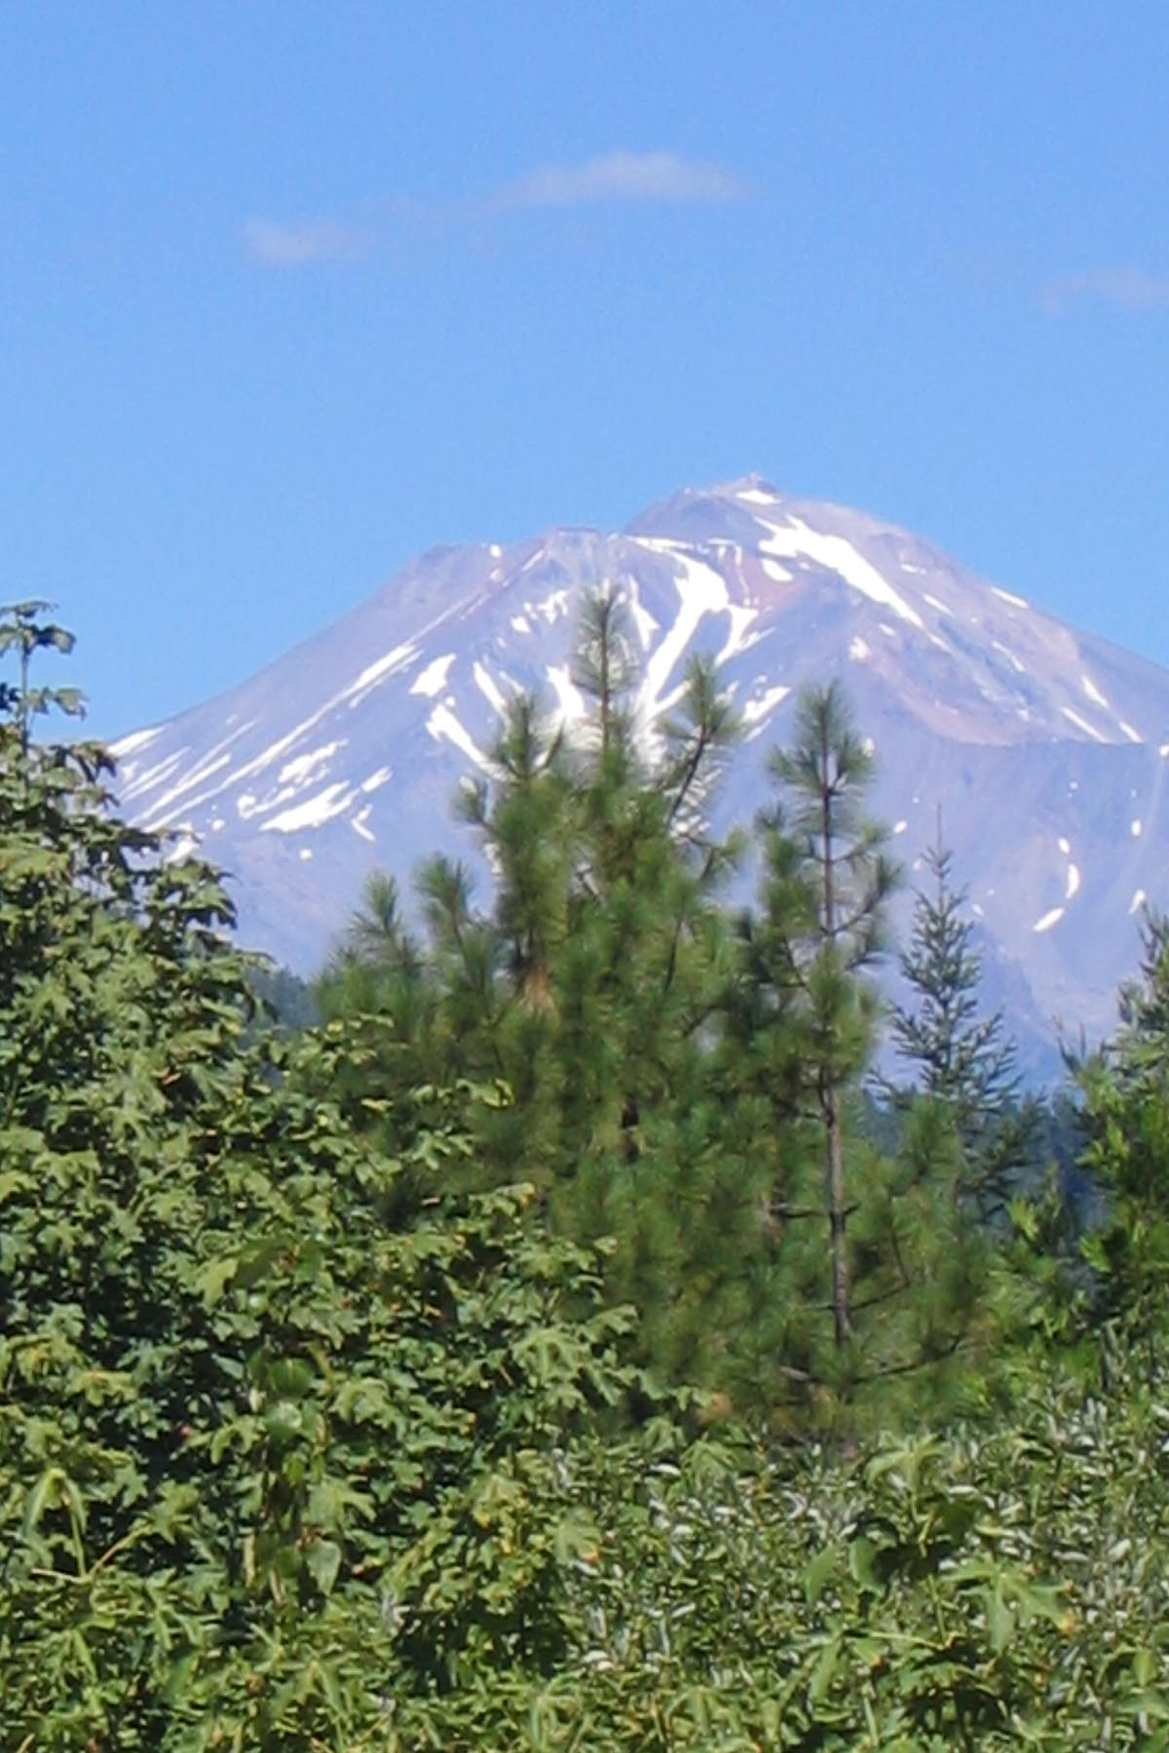
Mt. Shasta

I left Sacramento on a bright September morning and headed North on Interstate 5 through the farmlands of the Central Valley. Just past Redding and Lake Shasta, I was in the mountains of Northern California and headed for Central Oregon. I spent the night in Klamath Falls, Oregon ad headed for Crater Lake National Park.


Crater Lake

I had a chilly, but beautiful ride through Crater Lake then once again headed North on U. S. 97. I rode through evergreen forests until I reached Bend, when the land turned into High Desert and grassland.

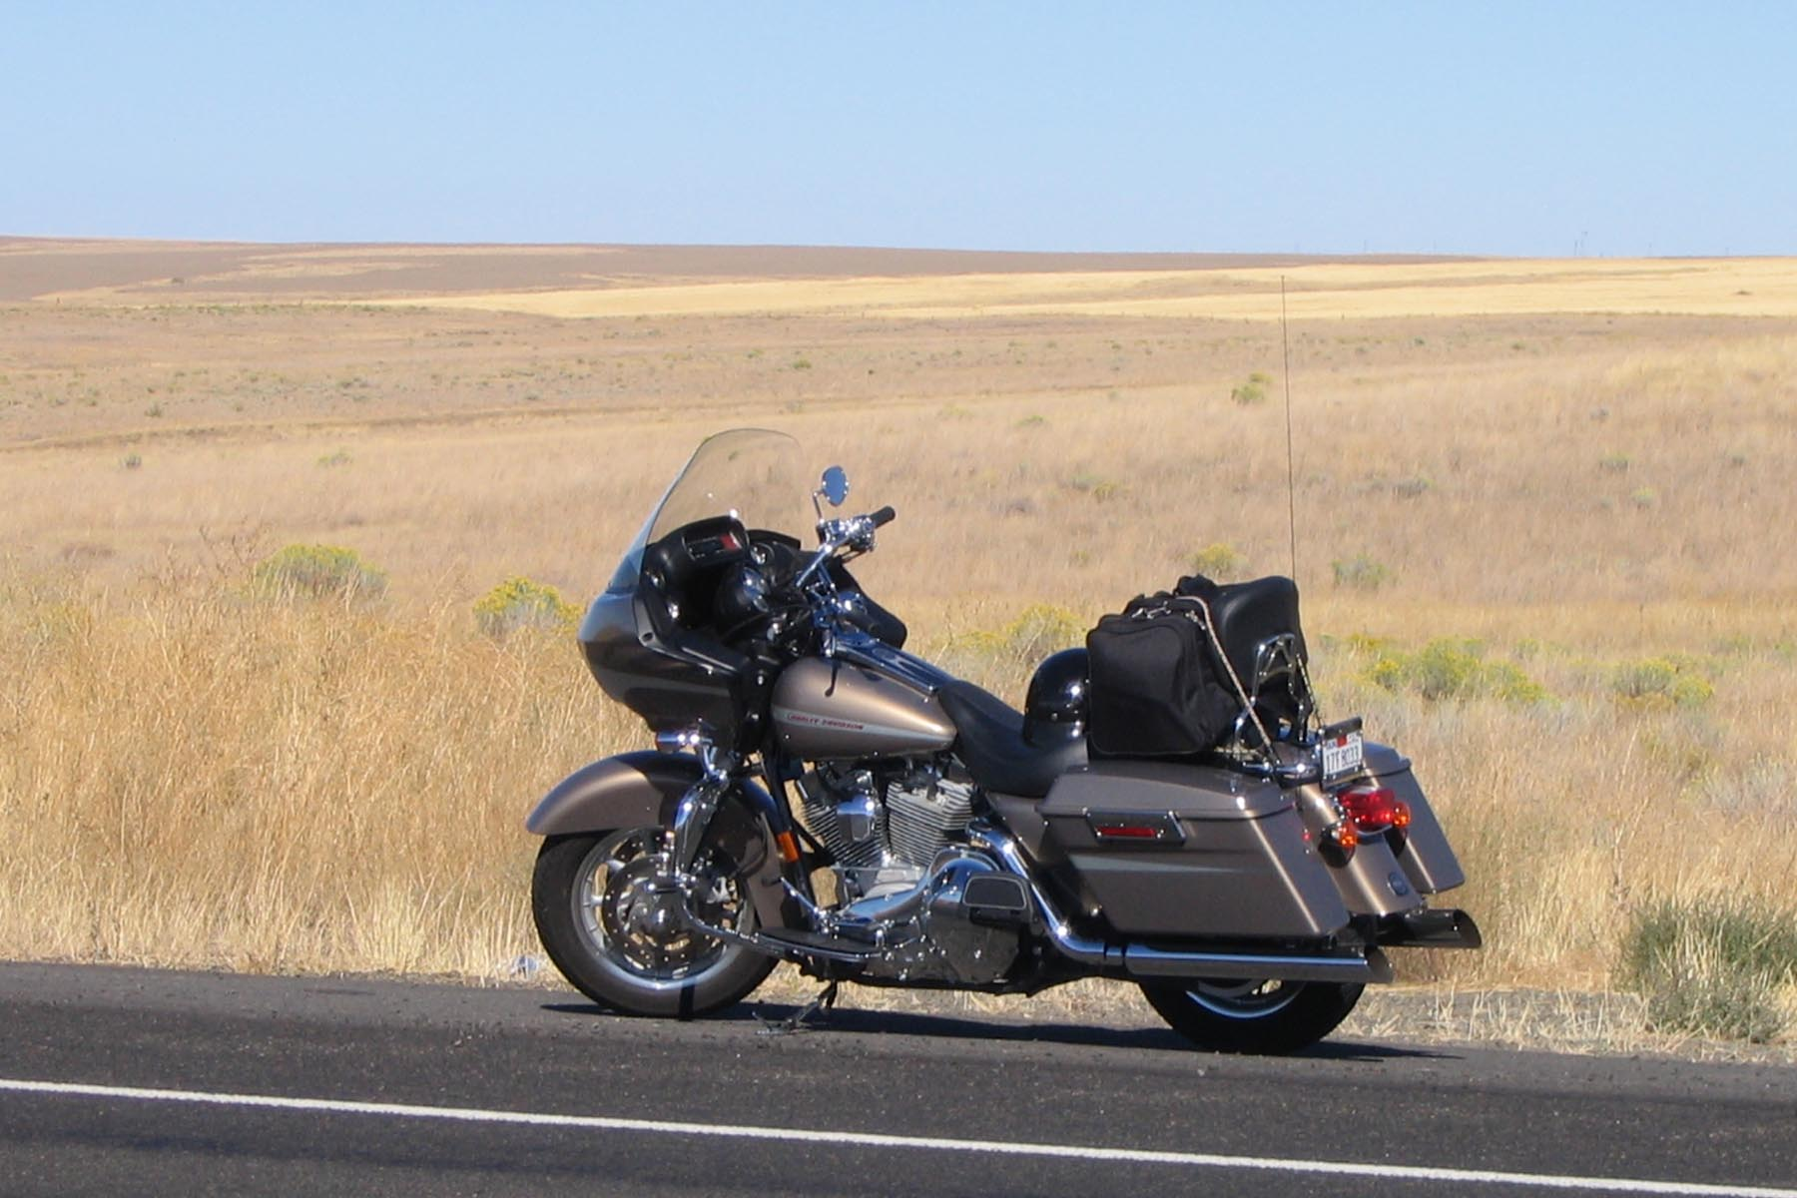
Northern Oregon

I crossed the Columbia River and headed into Central Washington for a night in Yakima. The next morning I packed and took a leisurely ride over the Cascade’s, around Mt. Rainier (too cloudy to see) and in to Seattle for the Reunion.

As usual, it’s always great to see old friends and meet new ones. Jack Barron and Mike Mason did a great job finding us a place to stay and things to do while we were there. The Reunion was a great success. Through the Raffle, 50/50, Auction, Sale of 17th FA Association stuff and Donations we put almost $2,500 into the Scholarship Fund. I would like to thank the following for their Donations and participation in the Auction:

Tom Kurtz,
Norm (Richard) Jones
Dan Lazenberry
Mike Mason
Don Arcenaux
Wallace Bates
Jack Stroud
Frank Tampone

I would also like to thank all of you that attended and made this a great Reunion. I hope to see all of you in Charleston, South Carolina in October.

After the Reunion I rode over to Bremerton on the west side of Puget Sound to visit some friends and then on to Kelso, WA. for the night. The next morning I crossed the Columbia River again and began a cold, foggy ride on US 101 down the Oregon Coast. Although chilly, it was a beautiful ride

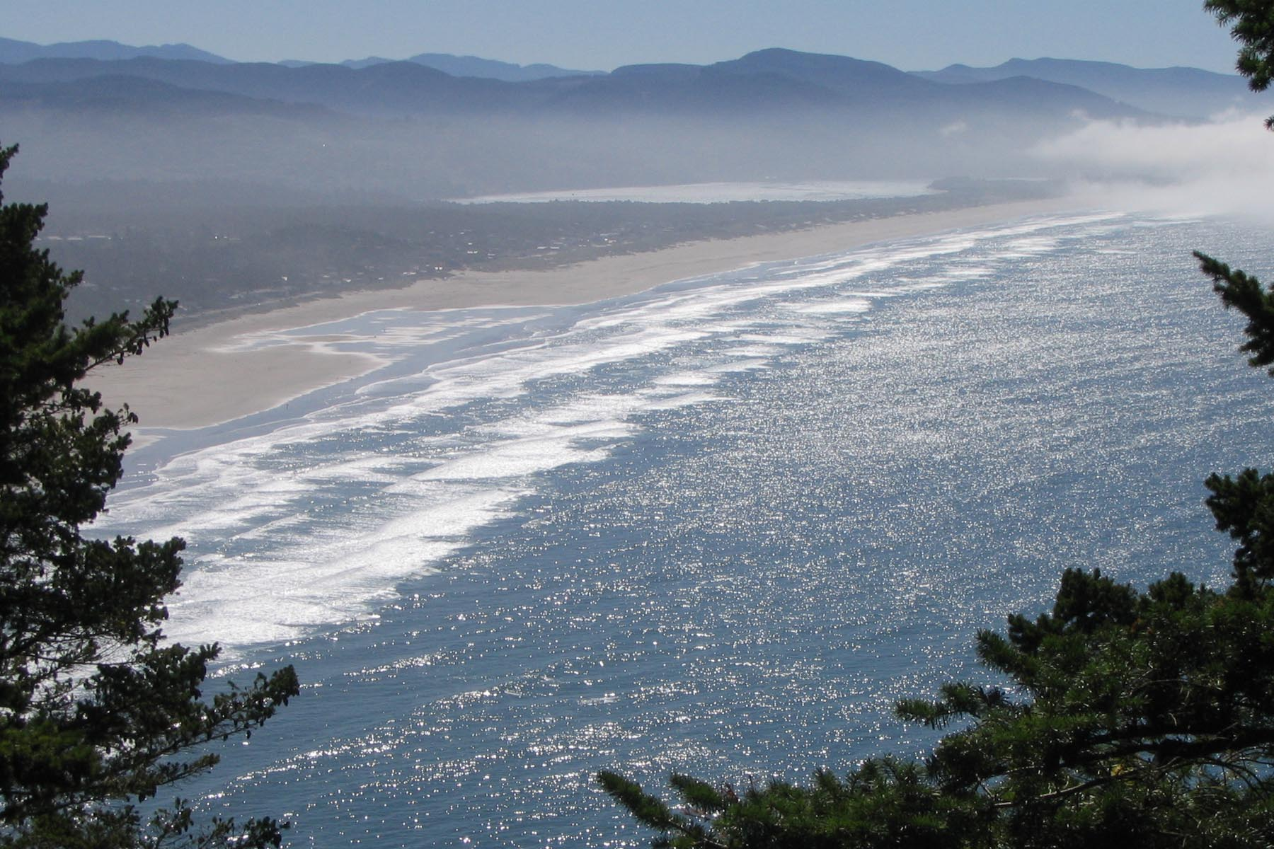
Oregon Coast
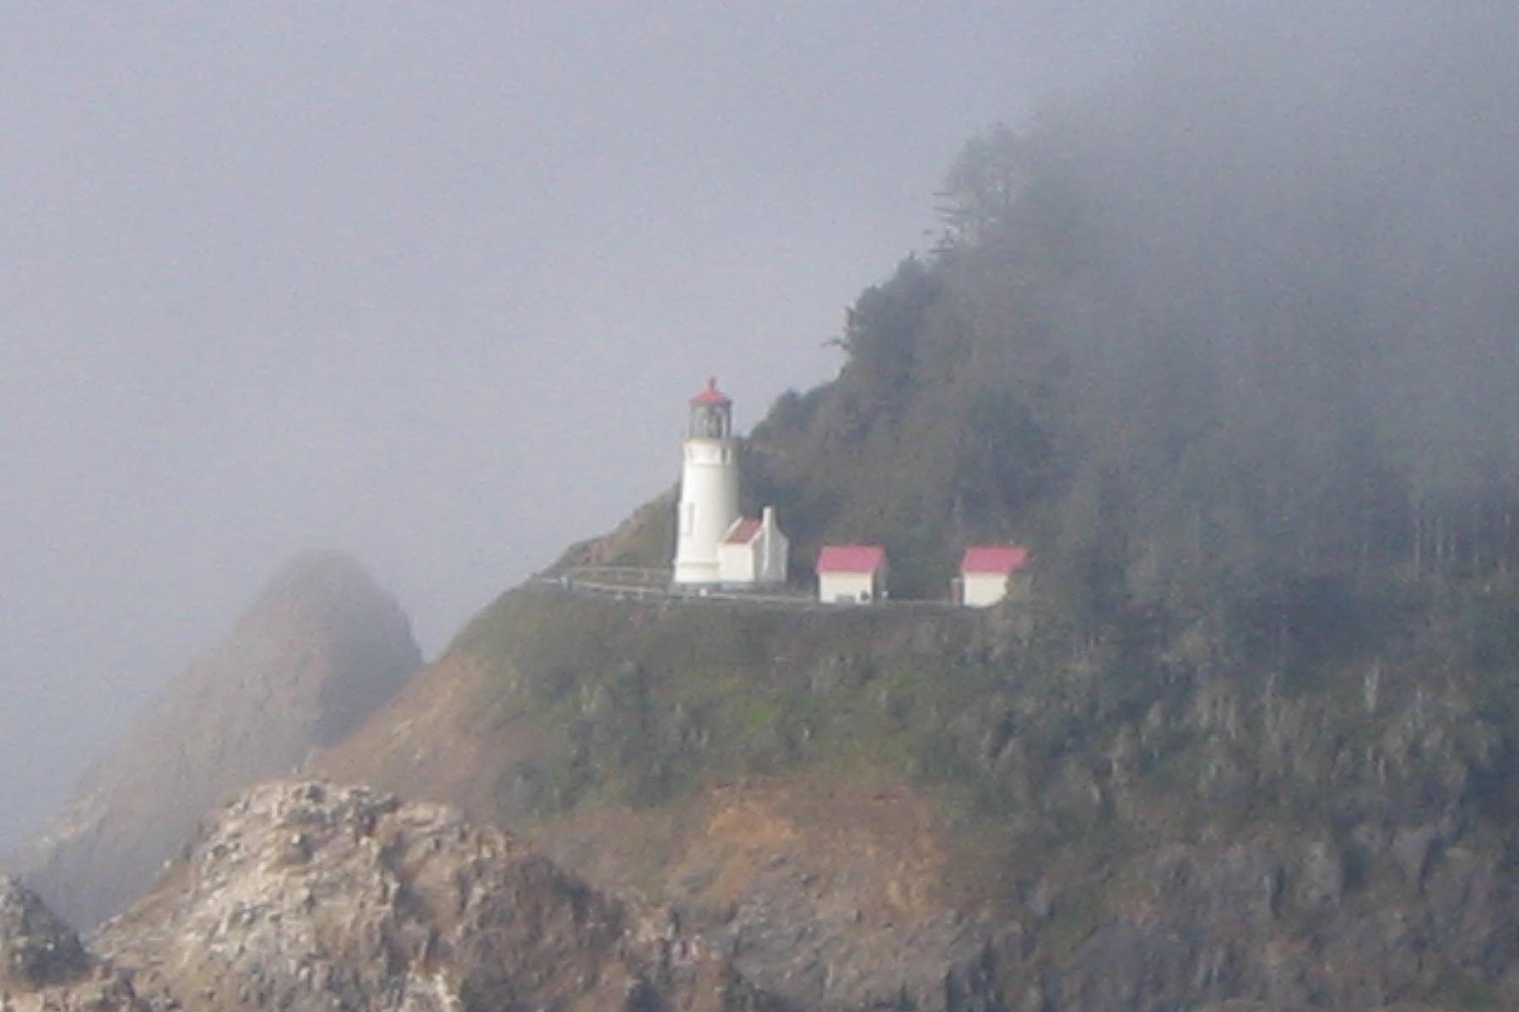
Heceta Head Lighthouse, Oregon

I spent the night in Coos Bay, Oregon and headed inland to get warm the next morning. When I hit I-5 I turned south and made a determined run home.

Since the founding of the Association in 1999 I have attended all of the Reunions, met a lot of great people, and been to places I have never been before and have had a great time doing it. Remember, it’s you, the members that make this organization what it is.

See you in Charleston,

Rich Siebe
Treasurer
17th Artillery Regiment Association

Association Finances as of January 1, 2006
General Funds: $
Scholarship Fund: $

Care Packages
Richard Smith
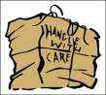 The Association shipped Care Packages to the Bull Dawgs of the 1/17th FA in December. The packages were shipped to 1st Sgt. Robert Brossard in Iraq to be distributed to the troops. The packages contained Slim Jims, chewing gum, peanuts, popcorn, crackers, playing cards, razors, shaving cream, and (2) donated copies of my book "One Stands Alone". The Association would like to thank the members who donated to this special cause. A second mailing of packages is being readied. Donation to the Care Package project will be accepted throughout the deployment and can be sent to Rich Siebe, Treasurer.

URGENT REQUEST: We need every 17th Artillery Veteran to keep his contact data current. Please notify us of any changes in your mailing or e-mail address. Contact any officer, or you may post your address by accessing the association’s home page and following the instructions. Contact me if you have any leads on any 17th vet. We need your assistance in keeping the association growing.
Home Page: http://www.17thartilleryregiment.org
Secretary: Jack Picciolo
1122 Lincoln St.
Lockport, IL 60441
(815) 838-3481
E-mail: Purrsfive@comcast.net
Web Page: http://persuaders65.org

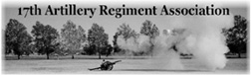

Association Officers 2006

Paul Fusco--- ------------------ President
Richard Smith ------------------1st Vice President
Jack (Jackie) Stroud ---------- 2d Vice President
John (Jack) Picciolo ---------- Secretary
Richard (Rich) Siebe --------- Treasurer
Thomas R. Kurtz--------- ----- Past President
Webster Cole ------------------ Chaplain
John (Jack) Picciolo ---------- Historian
Jack (Jackie) Stroud-----------Quartermaster
Vacant -------------------------- Parliamentarian
Vacant -------------------------- Judge Advocate
Vacant -------------------------- Program Director
Edward (Ed) Hitcher ---------- Webmaster

Committees:

Norman (Richard) Jones------Finance Committee Chairman:
Thomas R. Kurtz---------------2006 Scholarship Committee Chairman

This Newsletter, Castle # 7, was approved by the 17th Artillery Regiment Association Board of Directors

Paul Fusco
Association President
15 Jessica Court
Jackson, NJ 08527
((732) 886-6344
PFVET@optonline.net

