THE CASTLE NEWSLETTER
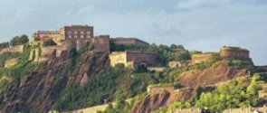
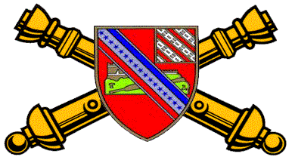
17th ARTILLERY REGIMENT

ASSOCIATION

______________________________________________________________________________________
Issue 8 July 2006

Heraldic Times
(Coat of Arms)
Shield:
Gules, a conventionalized castle of Ehrenbreitstein with ramp or on mount proper, debruised by a bendlet argent bearing two ribbons of the field and azure with seventeen mullets of the last. A sinister canton bendy of eight ermine and of the field.

Crest:
On a wreath of the colors, or and gules, a mount argent garnished vert, bearing a linden leaf proper charged with a fleur-de-lis argent.

Motto:
In Time of Peace Prepare for War.

Symbolism:
The field of the shield is red, the artillery color. The principal charge is the castle of Ehrenbreitstein bedruised by a bendlet carrying the American colors and seventeen stars, to signify the occupation of the castle by the 17th Field Artillery. The canton alludes to the arms of the 8th Field Artillery from which men were transferred to organize the 17th Field Artillery. The crest commemorates the two most noteworthy battle incidents. The White Mountain is for Blanc Mont. The leaf is taken from Verte Feuille Farm, on of the positions occupied by the regiment in the Soissons offensive; the linden leaf was chosen as being very common in that region. The fleur-de-lis is from the arms of Soissons.

DISTINCTIVE INSIGNIA
The distinctive insignia is the shield of the coat of arms.

President’s Letter
By: Richard Smith

Listen up! (It always seems that these two words grab a soldier’s attention!) Greetings to all Red Legs, their families and friends. I’m sorry that I haven’t been making many posts to the web site lately, but between family sickness and sickness of my own, I’ve been a little busy.
This is my first letter as President of the Association. I thank all the officers and others that have helped me get oriented as President and stood beside me during this learning process. I’d like to especially thank Norman Jones (“Dad”) and Tom Kurtz (“the wise man”) for their abundance of help.
Thanks to all for helping with the CARE packages last Christmas for the 1st Battalion in Iraq. I’ve received a certificate of appreciation from Lt. Col. Michael Borg and CSM Larry Werkheiser for our support. This certificate will be on display in Charleston, SC, at our reunion, so now you’ve got another excuse to be there. I’ve also received several challenge coins from the 1st Battalion that have Iraq on the backside to be auctioned at the reunion. Bring some big bucks for this auction!
Hopefully the Iraqi war is winding down. The CSM (Command Sergeant Major) has reported only two casualties to me since January right after they were deployed. Both were from a roadside bomb on 28 Jan. A Staff Sergeant was slightly injured from a small cut across his nose. He was back on duty that afternoon. On a more serious note, SPC Anthony Bentley was thrown from the vehicle during the same explosion thus breaking his neck.
Anthony and I have spoken several times. He was temporarily paralyzed from his neck down but he says he’s getting feeling back in his stomach. His Dr. thinks he’ll be walking by the end of summer after extensive physical therapy. Anthony is from Baton Rouge, LA. His family lost all to Hurricane Katrina, but according to his mother, things are going well now. It is my pleasure to inform you that Anthony has been awarded the Purple Heart on June 8, 2006. Please keep him in your prayers. His address is:

Spc. Anthony Bentley
5901 East 7th St
Attn: Ward V1
Long Beach, CA 90822
His phone number is (562) 826-8000 ext.5862.

I welcome all the new life members. They are listed under the Life Member Coin on page # 6.
Thanks to the scholarship committee for its time in granting two scholarships to Mercer Morrison of Pensacola, FL, And Kendra S. Ford of Byron, MI. They were both awarded $1000 each. Mercer is going into broadcast journalism at S. Miss. He is the grandson of WW II POW Ed Morrison. Kendra is going into interior design. Her sponsor was her grandfather, Jerry Pifer (1965-66 C/2/17). We wish these two young adults well in their careers.
Time is gaining upon us as our reunion gets closer. The reunion will be in Charleston, SC, which is a very historic city with plenty to do. If you haven’t done so already, please make your hotel reservations at the North Charleston Inn, 2934 W. Montague Ave., N. Charleston, SC 29418 (843) 744-8281. The dates are October 11-14 2006. When making reservations, be sure and inform the clerk that you are with the 17th Artillery Regiment.
My email (rsmith3024@nc.rr.com) and phone number are always open to anyone of this association. I might not be the fastest in responding, but I promise that I will be in touch should anyone have ideas, suggestions, comments, or whatever. This association belongs to all of you, and you are the wheels that run it. With your input of suggestions we can continue to improve. That’s the only way we can pass this great organization on to our future generations and those now serving proudly in the 17th Artillery Regiment. Pray for our troops and their safe return home. God Bless all the veterans of the 17th Artillery.

Past President’s Letter
By: Thomas R. Kurtz

I would like to thank Paul Fusco for the time and effort he put forward while he was president. Paul can be contacted by phone at (732) 886-6344.

Richard A. Smith, who was the 1st vice president, has assumed his position and will finish Paul’s term of office (2006-2007) in accordance with the by-laws. This leaves the position of 1st vice president open. Also, Jack Stroud has served his two year term as 2nd vice president. As the results of these position changes, there will be two association officers’ positions up for election at the next annual general membership meeting in October. If you are interested, please contact the president or any of the officers prior to the next annual membership meeting.

This was the third year that the association has offered its scholarship grants. The funds are taken from twenty-five percent of the following: annual membership dues, life membership fees, purchases of “gear” items (from the association quartermaster) and personal donations from members. Without the support of the general membership, this worthwhile program would not be possible. In addition, we need 3 to 5 members to serve as voters on the 2007 scholarship committee. Please contact the president.

The eighth annual reunion is also just right around the corner. If you are planning on attending and haven’t made your reservations, now is the time to do so. Don’t forget to bring your spouse, family and friends. I’m looking forward to seeing everyone at Charleston, South Carolina in October.

Most importantly, we all need to keep the soldiers of the 1st Battalion, 17th Field Artillery in our thoughts and prayers. The battalion is currently on its second tour in Iraq doing its part in this country’s fight in the Global War on Terrorism.

Former Battalion Commanders of the 2d Battalion, 17th Field Artillery

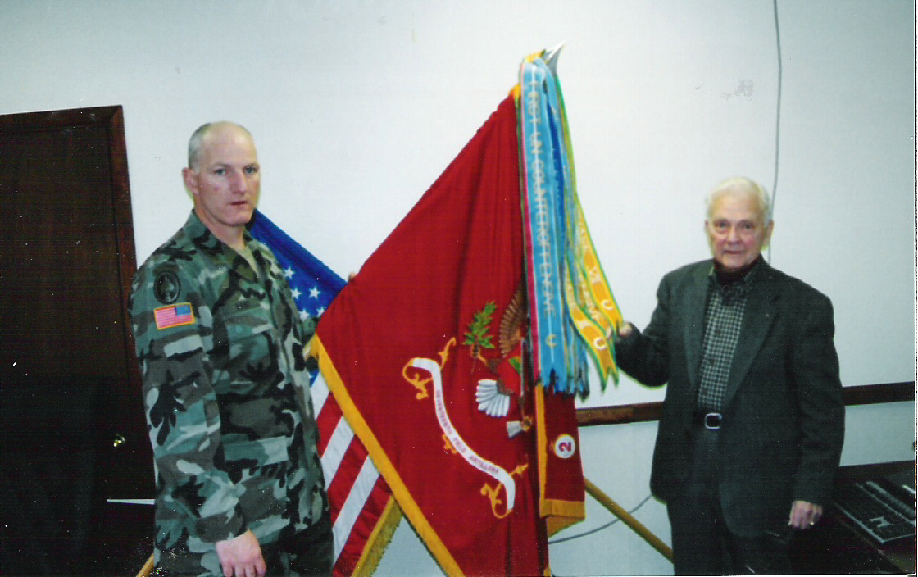

Lieutenant Colonel John S. Fant (left) shown with Colonel (Retired) Harry O. Amos (right), at the battalion’s headquarters Fort Carson, Colorado. LTC Fant and COL Amos exchanged correspondence while the battalion was station in Iraq. COL Amos was invited as a guest speaker for the battalion’s Saint Barbara Day celebration in December 2005. COL Amos is holding the Battalion’s Vietnam Campaign Streamers. COL Amos commanded the 2d Howitzer Battalion, 17th Artillery at Fort Sill, Oklahoma and in An Khe, South Vietnam. (July 1964-March 1966). LTC Fant commanded the 2d Battalion, 17th Field Artillery in South Korea, Iraq and at Fort Carson. (June 2003-December 2005).

2006 Scholarship Program
By Thomas R. Kurtz, 2006 Selection Committee Chairman



Since May 2004, we have awarded 5 grants totaling $4000! At the 2005 reunion, held in Seattle, Washington, those members present at the general membership meeting voted to offer three scholarship grants for 2006--two $1000 scholarships and a third for $600. Only two scholarship applications were received by the association’s scholarship committee chairman, and both were approved.

Mercer B. Morrison, a graduating senior from Booker T. Washington High School in Pensacola, Florida, was awarded $1000. Mercer’s planned major is Broadcast Journalism. He is the grandson of Charles E. Morrison, who served with Battery F, 17th Field Artillery during World War II. Charles was captured in Africa in 1943, and was interned as a Prisoner of War in Africa, Italy, Austria, Poland and Germany. Charles served from January 23, 1941 to October 15, 1945.

Kendra S. Ford, a graduating senior, attending Lake Fenton High School in Linden, Michigan, was also awarded $1000. Kendra plans to further her education in Interior Design. She is the granddaughter of Jerry E. Pifer, who served with Battery C, 2d Howitzer Battalion, 17th Artillery at Fort Sill, Oklahoma and deployed with the battalion to An Khe, South Vietnam, in August 1965. Jerry was honorability discharged from the service in March 1966.

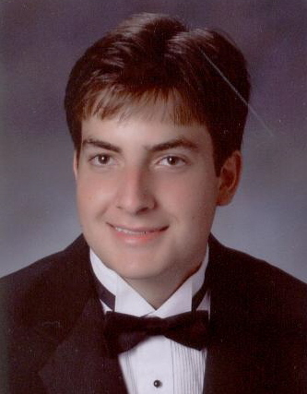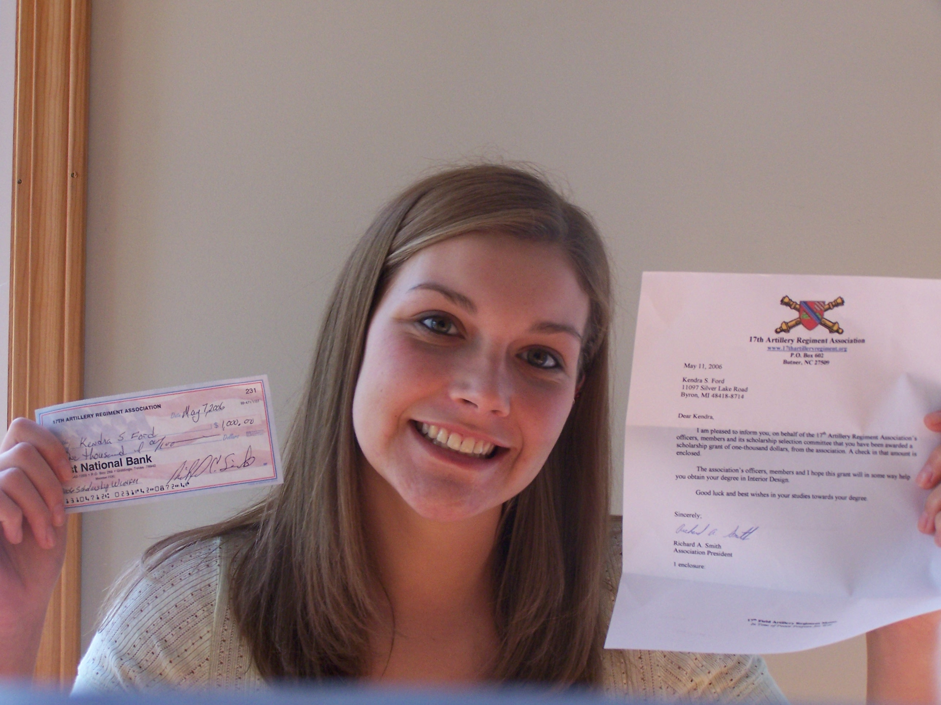
Mercer B. Morrison Kendra S. Ford

The third scholarship grant was not used and the funds remain in the scholarship fund.

Thanks to the voting members who served on the 2006 committee: GW Adkisson, Norman (Richard) Jones, Charles Riley, Richard A. Smith and Steven K. Wardrum.

The number of scholarship grants and amount of funds for 2007 will be determined and voted on at the general membership meeting during the 2006 annual reunion, October 14th, in Charleston, South Carolina. Details for the 2007 scholarship grants will be announced by the president following the reunion.

Reunion
By: Norman R. Jones
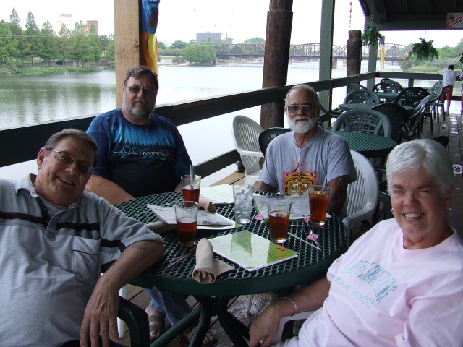
Waco, TX--- June 1, 2006 From left to right Norman R. Jones, Richard Siebe, Dan Matulich & Annette Jones

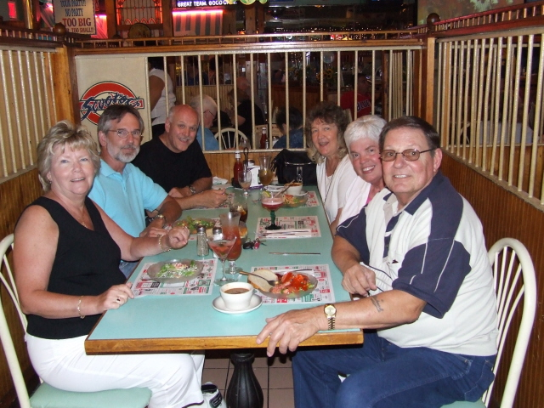
Jackson, New Jersey---June 23, 2006 Jones’ 44th anniversary. Left to right Nancy & Ed Hitchner, Paul & Jane Fusco, Annette & Norman R. Jones.

The year of 2006 has slipped by pretty fast. We have had the opportunity to meet with friends twice this year as you can see from the pictures above.

Annette and I are preparing for our trip to Charleston, South Carolina, my home town, for the reunion during 11-14 October 2006. I’m sure it will be an exciting trip. We will visit a lot of Historic places that were of no interest to me as a kid. During those younger years I just wanted to be on my own, so I joined the Army. As I have gotten older, I realize and appreciate my hometown’s history.

It is now time for all to finalize their plans to attend. Get your registration in to our treasurer. Lets all meet and have the reunion of all reunions. You will enjoy your time there! See you in Charleston!

630th Field Artillery Battalion and 537th Field Artillery Battalion

On March 1, 1944, the 17th Field Artillery Regiment was reorganized and re-designated. The 2d Battalion was re-designated as the 630th Field Artillery Battalion. After inactivation of the 630th Field Artillery Battalion
on February 22, 1946 at Camp Kilmer, New Jersey, the 630th Field Artillery Battalion was reactivated at Fort Sill, Oklahoma, on August 1, 1946. The mission of the battalion was to serve for the Artillery School. The battalion was equipped with three types of weapons systems; the 8inch towed Howitzer (tractor-drawn), the 8 inch Howitzer (self-propelled) and the 240mm Howitzer (tractor-drawn). In addition, the battalion had twelve 105mm Howitzers (towed) for use in school troop problems.

The 630th Field Artillery Battalion was re-designated, on February 5, 1947, as the 537th Field Artillery Battalion and moved to Camp Carson, Colorado.

In 1949, the 537th Field Artillery Battalion along with other units from Camp Carson participated in rescue work. “Operation Hay Lift” was a disaster relief project in the snowbound states of Wyoming and South Dakota. The units from Camp Carson opened 9,000 miles of snow bound roads to liberate 25,000 snowbound persons.

In January 1950 the 537th Battalion took part in the Alaska maneuvers, “Operation Sweetheart”, designed to test the northern defense of the American continent. During the months of May, June and July 1950, Battery B and Battery C were levied from the battalion and shipped to Korea to participate in the Korean War as part of the 17th Field Artillery Battalion. The 537th Field Artillery Battalion remained at Camp Carson throughout the Korean War.

The beginning of the year 1953 found the battalion stripped of all personnel, with the exception of a skeleton cadre which was preparing for a training cycle to take five-hundred recruits and build them into a new battalion. At the end of the six months training cycle, the battalion three firing batteries were tested under the Army Training Test 6-1 and received an overall average of 90%. As a result, the Fort Sill Artillery School selected the battalion to test a newly decentralized fire direction system. After the testing period, the battalion completed Army Training Test 6-2 and Army Training Test 6-3 in December 1953. The battalion received ratings of superior and excellent respectively.

In early 1954, the battalion started preparation for their move to Fort Sill, Oklahoma. After a three day motor march, from Camp Carson, the battalion arrived at Fort Sill on March 25, 1954. The new mission of the battalion was to support the Artillery School 100%. On September 5, 1954, the battalion was relieved from school troop requirements to undertake battery and battalion tests. After the successful battery and battalion tests held in October and November, the battalion returned to part time school troop requirements, combined with a post training cycle.

The majority of activity of the battalion during 1955 from January to May was preparation for “Operation Breechblock Able”, a five day field maneuver held 3-7 May 1955. In March of 1955, the battalion moved to a new area on post and was assigned to the 52d Artillery Group. In late October 1956, the battalion moved, by convoy, to Fort Chaffee, Arkansas, to train and qualify basic RFA six month trainees in the Field Artillery. Battery A, 6th Armored Field Artillery was attached to the 537th at Fort Chaffee during this time period. The battalion with the training cycle completed returned to Fort Sill on December 15, 1956.
The mission of the battalion throughout 1957 was to maintain a readiness potential required by STRAC classification; support the Artillery and Missile School by providing demonstration teams in artillery organization, techniques and fire; and provide research and training as directed. On September 25, 1957, the battalion was reorganized with strength of 37 officers, 2 warrant officers and 537 enlisted.

The 2nd Howitzer Battalion (105mm towed) 17th Artillery was activated and designated on June 25, 1958, with the personnel and equipment to be provided from the 537th Field Artillery Battalion. With the transfer of its equipment and personnel, the 537th Field Artillery Battalion deactivated. The mission of the 2nd Battalion was to support the United States Army Artillery and Missile School, maintain a combat readiness in accordance with STRAC requirements, provide artillery training and retraining of artillery replacements, and provide personnel for Department of the Army experiments as directed.

537th Field Artillery Battalion and 17th Artillery Battalion (reorganized and re-designation)

Battery A, 17th Field Artillery Battalion (Inactivated June 1, 1958) was reorganized and re-designated as Headquarters and Headquarters Battery, 1st Howitzer Battalion, 17th Artillery (organic elements constituted April 24, 1958 and activated June 1, 1958).

Battery C, 17th Field Artillery Battalion (Inactivated June 1, 1958) was reorganized and re-designated as Headquarters and Headquarters Battery, 2d Howitzer Battalion, 17th Artillery, activated June 25, 1958 (organic elements concurrently constituted).

Battery B, 17th Field Artillery Battalion (Inactivated June 1, 1958) was reorganized and re-designated as Headquarters and Headquarters Battery, 3rd Howitzer Battalion, 17th Artillery (organic elements constituted June 1, 1958 and activated June 25, 1958)

Battery A, 537th Field Artillery Battalion (Inactivated June 25, 1958) was re-designated April 20, 1959 as Headquarters and Headquarters Battery, 4th Howitzer Battalion, 17th Artillery; concurrently, withdrawn from the Regular Army; allotted to the Army Reserve, and assigned to the Third United States Army (organic elements concurrently constituted) Battalion activated May 1, 1959 with Headquarters at Raleigh, North Carolina.

Battery B, 537th Field Artillery Battalion (Inactivated June 25, 1958) was re-designated March 19, 1959 as Headquarters and Headquarters Battery, 5th Howitzer Battalion, 17th Artillery; concurrently, withdrawn from the Regular Army, allotted to the Army Reserve, and assigned to the 90th Infantry Division (organic elements concurrently constituted). Battalion activated April 1, 1959 with Headquarters at Beaumont, Texas.

Battery C, 537th Field Artillery Battalion (Inactivated June 25, 1958) was re-designated March 24, 1959 as Headquarters and Headquarters Battery, 6th Howitzer Battalion, 17th Artillery; concurrently, withdrawn from the Regular Army, allotted to the Army Reserve, and assigned to the Fourth United States Army (organic elements concurrently constituted). Battalion activated April 1, 1959 with Headquarters at Bogalusa, Louisiana.

Headquarters and Headquarters Battery, 17th Field Artillery Battalion (Inactivated June 1, 1958) is re-designated as Headquarters and Headquarters Battery, 7th Howitzer Battalion, 17th Artillery, and assigned to the 2d Infantry Division (organic elements concurrently constituted). Battalion activated May 2, 1960 at Fort Benning, Georgia

Headquarters and Headquarters Battery 537th Field Artillery Battalion (Inactivated June 25, 1958) was re-designated July 31, 1959 as Headquarters and Headquarters Battery, 8th Howitzer Battalion, 17th Artillery. Activated August 1, 1967 at Fort Campbell, Kentucky (organic elements constituted April 18, 1967 and activated August 1, 1967)

References:

- Lineage and Honors, 1st Battalion thru 8th Battalion, 17th Field Artillery Regiment
- History of the 2d Howitzer Battalion, 17th Artillery, Technical Library, USAAMS, Fort Sill, Oklahoma, dated March 1969

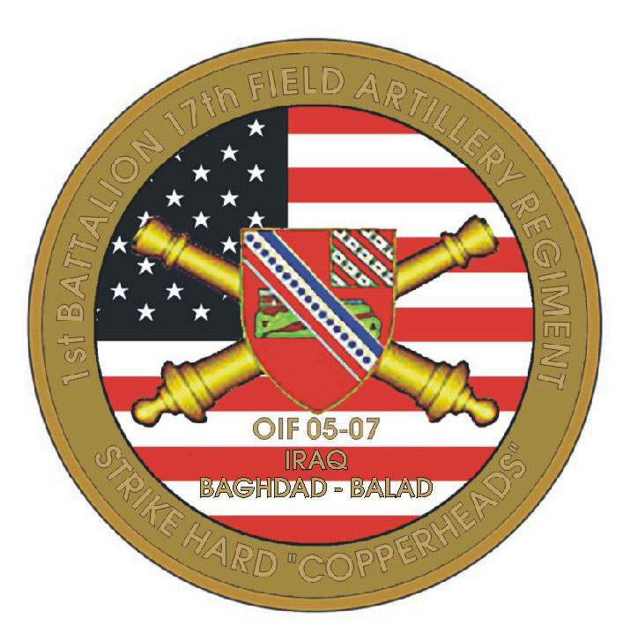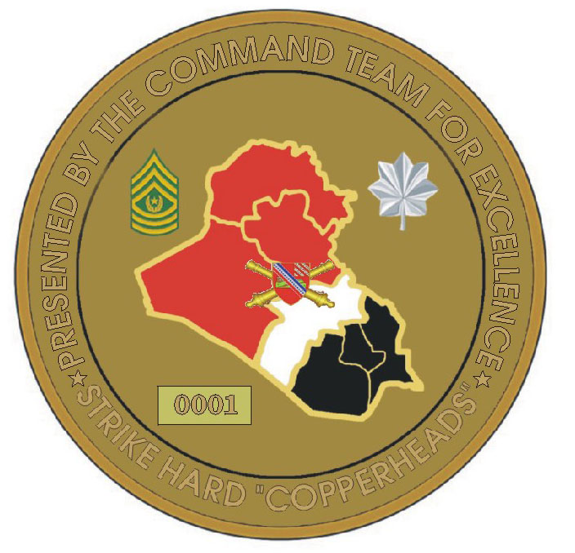
1-17th FA Challenge Coin OIF

Counter-Battery
By Dick Graves

If I were to ever write a book about my memories of the Korean War, this would be the prime chapter – my 15 minutes of fame. Fifty-three years have dulled my memory somewhat, but I remember this incident as if it were yesterday.

I was trained at Fort Sill, Oklahoma, as a liaison pilot and arrived in Korea in April 1953, just four months before the war was over. I was assigned to the 17th Field Artillery Battalion, which was part of the I Corp (First USD Corps.) Corps Artillery consisted of seven battalions responsible for the operations on the Western half of Korea approximately seventy miles of the front. Our battalion of eight-inch howitzers was spread out so we could cover the entire front.

The front lines were fairly static. However, we, as well as the enemy, were jockeying for real estate before the Armistice was signed on July 28, 1953. We pounded the enemy everyday until the cease-fire order. As a liaison pilot, it was my job to fly an observer, to keep his eyes on the target at hand, and secondly to look for targets myself. On about a third of my thirty-seven combat missions, I found something to call in a fire mission, usually anti-aircraft fire, enemy artillery fire or sometime enemy troops.

A typical battalion artillery air section consisted of two pilots and two observers (all officers), seven enlisted men, two L-19 aircraft, a jeep, a 3/4-ton truck and a Herman Nelson heater to melt the ice off the aircraft wings before take offs in the winter. The enlisted men were aircraft mechanics, drivers and one cook. We had autonomies capabilities although we were fortunate enough to be housed and co-mingled with the six other battalions in the corps artillery air section, which added three pilots and planes. That gave us sixteen planes and pilots so that we could operate on a schedule of two combat missions on one day and only one mission on the next day. A mission consisted of at least two and half hours over the front at observing altitude from first light until dark. If we were busy with a mission, we would stay and observe until we ran out of gas (four plus hours of fuel on board.)

All fire missions were handled by corps operations (S-3). We never knew which outfit we would be firing, but a fair amount of time, we got the 17th Field Artillery, also known as the Persuaders. We were called “The Eyes of the Persuaders” and our eight-inch howitzers were the most accurate pieces in the whole corps. All the pilots made it a point to know where our twenty-one corps batteries were located. We also requested the maximum ordinate (projectile height), as we did not want to get in the way and shot down by our own fire.

Now, for my greatest fire mission. It was a bright warm sunny day and my observer was assigned a mission to shoot at a known and sometimes active target that we called “concentrations.” For example, this particular concentration may have been named Charlie Dog, and we had circles on our map showing a number of these concentrations. We always flew at an altitude of 10,000 feet to avoid most of the enemy anti-aircraft, which we called “able-able.” This day we were at 10,000 feet shooting Charlie Dog (CD), and in order to keep my observer’s eyes on the target, I would dive the L-19 to about 9,500 feet to pick up enough air speed to do a quick chandelle (180 degree turn) so the observer did not lose contact with his target while we were turning around.

The controls of an L-19 are very sluggish at 10,000 feet, so it was relatively hard to reverse direction without losing precious observation time. We always reversed direction when we were waiting for the ground artillery men to cut their fuses and load. They would announce, “On the way!” and give us the time of flight and the maximum ordinate. Then we would figure out how to be out of the trajectory path and be able to observe the target as the projectile hit.

Pulling out of one of the chandelle turns, I observed a flash in the distance. It came from the side of a hill a great distance from the target that was concentration Charlie Dog. I instantly knew what that flash was – it was a large enemy artillery piece that was being fired from a cave on a hill near the Imgin River. I quickly calculated the coordinates from the map and got on the radio saying something to the effect that I had found a target worth getting, and if I recall, it went like this:

Boxcar 3, this is Gearshift 14, Fire Mission, over. (Corps operations knew it was me by Gearshift 14; my observer was Gearshift 11, and this changed weekly)

Gearshift 14, send your mission, over.

Gearshift 14, Fire Mission, counter-battery (that told them I had seen the flash.) Coordinates (8digits), artillery piece in defilade.

Now is when you start waiting and wondering if they are ever going to get a round in the air. Operations (Corps) take the coordinates and assign the best artillery battery for the mission. Fortunately, they assigned my mission to our Charlie battery, whose commander was Lt. Penland, a fellow Texan from around Waco, and a friend. My fire mission request included the artillery piece location, time of flight, when fired and max ordinate (height of projectile). I did not need to specify type of round, but I am sure S-3 sent How Easy (high explosive) with impact fusing.

It seemed like the wait was forever (probably 15 to 20 minutes), but in that time I got to observe another flash from the same hole in the side of the hill. They finally called back and said, “Gearshift 14, projectile is on the way. Time of flight is two minutes, six seconds, and maximum ord is 17,000 feet.” Those two minutes seemed like two months when the projectile finally hit, but it was over the target. I called back and said, “Over Line Over, Repeat Range, Fire for Effect”. That round was so close to the gold mine, probably the closest I have ever seen an artillery round being on a target.

The next round hit the gold mine. I screamed, “Target, Repeat Range, Fire For Effect, Large Secondary Explosion, Another Secondary Explosion, Black Smoke Coming From the Target.” That was exemplary shooting. I have fired at targets until I ran out of fuel without ever hitting or getting results like this. I finally said, “Several secondary explosions, unable to observe target due to large quantities of black smoke, suggest cease fire.” That was my proudest moment. This is what they sent me to flight school and artillery school for (I don’t mind ending this sentence with a preposition since it excites me just to think of this moment).

Then in all my excitement, I did something foolish and stupid. I hollered on the radio “Damn good shootin’, Charlie.” I sounded like an excited schoolboy instead of a mature 22-year old 1st Lieutenant. We never cuss or identify an outfit on the radio since the enemy monitored all our radios. Fortunately, I was lucky—no one called me down for this. My observer went to the S-3 for debriefing (as usual), and the next I hear of this mission was next week’s corps newsletter. It said something like this: “The mission of the week was the counter battery mission fired by Charlie Battery of the 17th Field Artillery Battalion and was observed by the 17th FA air officer.” I never did find out what the target contained, but it must have been an artillery piece, an ammunition dump and a fuel depot. This was my crowning day although the Persuaders operating those 8 inch howitzers should get all the credit.

Life Member Coin

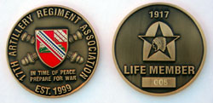

17th Artillery Regiment Association Life Members (New)

The following have become life members of the 17th Artillery Regiment Association since the January 2006 newsletter.

066 H. Bruce Latour (Battery C, 2d Battalion, 17th Field Artillery 1969-1970)

067 Wiley A. Jarrell (Battery C, 17th Field Artillery Battalion 1955)

068 James H. Sanders (Battery C, 2d Battalion, 17th Field Artillery 1967-1968)

069 Raymond C. Gomez (Battery C, 2d Battalion, 17th Field Artillery 1969-1970)

070 Charles G. Ross (Battery B & Headquarters Battery, 2d Howitzer Battalion, 17th Artillery 1965-1966)

071 Neal P. Fouts (Service Battery, 2d Battalion, 17th Field Artillery 1968 and Battery A, 3rd Battalion, 17th
Field Artillery 1969)

072 Dave Bickler ( Battery A, 2nd Howitzer Battalion, 17th Field Artillery 1966-1967)

17th Artillery Regiment Association
2006 Paid Members

- Wardrum, Steve September 24, 2005
- Kelly, Shelton September 24, 2005
- Detreville, John October 24, 2005
- Ryan, Bert October 27, 2005
- Blubaugh, Daniel October 27, 2005
- Nadeau, Roger October 27, 2005
- Caiella, James October 27, 2005
- Stanley, James November 7, 2005
- Armstrong, Buddy November 9, 2005
- Rowell, Dave November 9, 2005
- Colgan, Deborah November 12, 2005
- Selis, William November 15, 2005
- Simonet, Marcel November 21, 2005
- Cody, Jerry (Doc) November 23, 2005
- Labak, Robert L. November 30, 2005
- Anderson, Mark November 30, 2005
- Steen, Gary November 30, 2005
- Sadler, Larry December 2, 2005
- Trudeau, Michael December 7, 2005
- Ahonen, Edwin December 19, 2005
- Ryan, John December 26, 2005
- Bregoff, Bruce December 30, 2005
- Squadrille, Michael January 3, 2006
- Tanner, George January 3, 2006
- Runice, Raymond (Doug) January 12, 2006
- Skirvin, Ron January 12, 2006
- Mason, Ronald January 21, 2006
- Widener, James January 23, 2006
- Comeaux, Ray January 23, 2006
- Jones, Tom January 23, 2006
- Hill, Richard January 29, 2006
- Brooks, Donald January 29, 2006
- Swanson, Toby February 2, 2006
- Hall, Avery February 2, 2006
- Irwin, Gerry February 2, 2006
- Gerhardt, Stephen February 3, 2006
- Arcenaux, Donald J. February 11, 2006
- Torres, Walter February 24, 2006
- Carra, Jeffery February 24, 2006
- Cahoon, Hollis April 22, 2006
- Haase, Albert June 9, 2006
- Frowein, James June 9, 2006

Urgent Request

We need every 17th Artillery veteran to keep his contact data current. Please notify us of any changes in your mailing or e-mail address. Contact any officer, or you may post your address by accessing our home page and following the instructions. Contact me if you have any leads on any 17th vet. We need your assistance in keeping the association growing.

Home Page: http://www.17thartilleryregiment.org
Secretary: Jack Picciolo
1122 Lincoln St.
Lockport, IL 60441
(815) 838-3481
E-mail: Purrsfive@comcast.net
Web Page: http://persuaders65.org

A Short Note from the Treasurer
By Rich Siebe

Our next reunion in Charleston is coming up in October! Have you got your reservation money in if you are planning to attend?

I love to give money away--that’s the best part of being treasurer. This year we were able to give out two $ 1,000 scholarships to Mercer B Morrison, grandson of Charles Morrison, Battery F, 17th Artillery Regiment (WWII), and Kendra S. Ford, granddaughter of Jerry Pifer, Battery C, 2nd Battalion, 17th Artillery (Vietnam). We were also able donate $ 937 from the association and member donations for Christmas care packages for the 1st Battalion, 17th Artillery currently serving in Iraq.

I hope to see all of you in Charleston.

Association Finances as of June 30, 2006
General Funds: $3,966.84
Scholarship Fund: $6,995.17
Total in Bank $10,922.01

Association Officers 2006
Richard A. Smith -------- President
Vacant -------------------- 1st Vice President
Jack (Jackie) Stroud ---- 2d Vice President
John (Jack) Picciolo ---- Secretary
Richard (Rich) Siebe --- Treasurer
Thomas R. Kurtz ------- Past President
Webster Cole ------------ Chaplain
John (Jack) Picciolo ---- Historian
Jack (Jackie) Stroud ---- Quartermaster
Vacant -------------------- Parliamentarian
Vacant -------------------- Judge Advocate
Vacant -------------------- Program Director
Edward (Ed) Hitchner –Webmaster

Committees:

Finance Committee Chairman - Norman (Richard) Jones

2006 Scholarship Selection Committee:
Chairman ----------------- Thomas R. Kurtz
Secretary ----------------- Jack Picciolo
Treasurer ----------------- Rich Siebe
Voting Members are---- GW Adkisson
Norman Jones
Charles Riley
Richard Smith
Steven Wardrum

This newsletter, Castle # 8, was approved by the 17th Artillery Regiment Association Board of Directors.

Richard Smith
President

